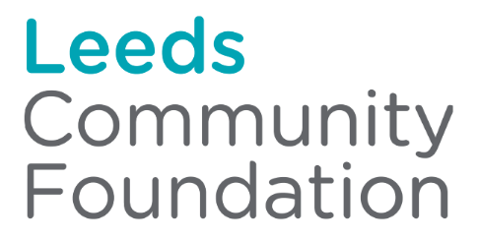
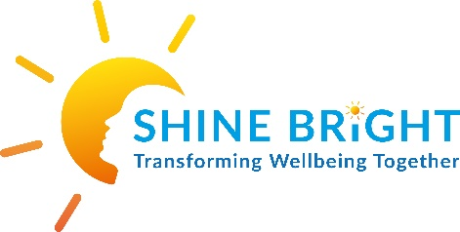

Shine Bright – That’s a WRAP project
Trauma Informed Work in Communities Grant – Year 2
2023-2024 Impact Report

Who we are and what we do
Shine Bright (NS) CIC is a Community Interest Company set up to support children and young people’s emotional and mental health needs across the city of Leeds. Shine Bright provides group and individual therapeutic wellbeing support that aids children, young people and families to transform their wellbeing together. The support teaches communities to self-care, to get well and stay well, to support others and to prevent crisis now and in their future. Support is offered through bespoke creative, and activity based individual therapeutic support sessions, a structured 12-week peer support group programme, an ongoing peer support group for all and the opportunity to become a trained volunteer peer facilitator.
Shine Bright is guided by the ethics of WRAP©️ ‘The Wellness Recovery Action Plan ® which is an evidenced wellness programme that offers sustained, longer-term behaviour change through the creation of a personalised Wellness Plan and Crisis Plan per individual. The founder of Shine Bright is an Advanced Practitioner of this approach and advocates the benefits of trauma informed practice, lived experience and peer support, utilising the strengths and skills of its communities. Shine Bright provides not only support but opportunity for communities to upskill and learn to support their peer communities through training, volunteering and employment, under the supervision and guidance of trained WRAP facilitators and Advanced Practitioners.

‘My time spent in Shine Bright has really increased my confidence over the past few years. This is because it offers a safe space to discuss mental health and receive support and advice. Being able to talk about mental health has increased my social skills and confidence as well as making me fully believe in myself in overcoming challenges in the future. I also have made solid friendships in the group and spend time with them outside the group.’ Male, 21yrs
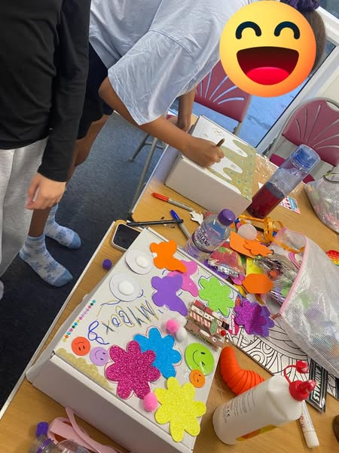
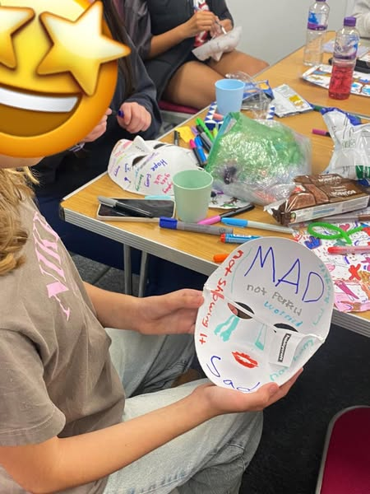

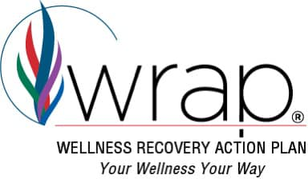

How Shine Bright has identified they work in a trauma informed way

Four R’s of Trauma informed Care
These help us to practice in a Trauma informed way. Detailed below is how Shine Bright believes it operates in a trauma informed mindset

Realize | Recognise | Respond | Resist – Re-Traumatisation
Realise the widespread impact of trauma and understand potential paths for recovery | Recognise the signs and symptoms of trauma in clients, families, staff, and others involved with the system | Respond by fully integrating knowledge about the trauma into policies, procedures and practices | Resist – Re-Traumatisation of children as well as the adults who care for them
Shine Bright recognises that it is not for the organisation to define somebody’s trauma/ somebody’s ACE. If an individual’s experience of an event determines it is traumatic then their experience of the event is validated. This impact can affect all areas of a person’s life and they are supported holistically not as a diagnosis or series of problems to fix.  Shine Bright does not create barriers in the referral criteria to prevent someone’s access to support, when they self-define that they need the support, they are engaged in a way comfortable to them to ensure it is the correct support for them and they are fully informed about the support offer  Shine Bright supports the individual to manage and cope with the impact of the event/s through different approaches.  1:1 support, drop-ins, wellness and crisis prevention programmes. Ongoing peer support, opportunities for goal setting, growth, training, paying it forward through volunteering and even employments as WRAP peer facilitator.  Shine Bright supports into other needed support and connections with wider community protective factors and Wellness Tools. | Shine Bright supports all involved in WRAP to reframe signs and symptoms as normal reactions to abnormal experiences that they have been through. Communities understand their triggers, their wellness and when they are declining in wellness. Learn how to action plan, about their Wellness tools and how to cope with challenging and stressful situations.  Through a peer support model the individual, with new supporters and protective factors, defines their own individualised wellness and crisis plan whilst being supported through the journey by all levels of role modelling – the staff, peer facilitators, peer participants, their family and wider services they may require.  What is unique about WRAP is that all those that deliver the programme have undertaken their own WRAP and understand and acknowledge their own wellness needs.  Shine Bright provides a WRAP contract for staff to be able to devise how to inform the organisation/ co-facilitator if their wellness declines and how we as an organisation support this and step in.  WRAP is co-delivered by lived-experience individuals drawing on the assets the community can bring to the approach. | All Shine Bright policies , procedures and practices are informed by WRAP Values and Ethics that are developed by adult mental health service users for communities in need, therefore integrate trauma informed practice throughout the whole organisation.  Shine Bright operates with the universal expectation that trauma has occurred. Therefore Trauma informed principles of care are integrated into the whole practice and delivery model of Shine Bright.  Trauma informed care approaches benefit those who have and have not experienced trauma. This is Shine Brights delivery model for all  All those delivering WRAP have to adhere to and uphold all WRAP Values and ethics. | Shine Bright does not wish to re traumatise its cohorts. Support is not offered based on restrictive referral criteria that focuses on a deficit model.  It is for communities to identify our support is right for them not that they are right for Shine Bright. If communities recognise, they need support Shine Bright is there to offer it.  Shine Bright does not focus on  ‘What is wrong with you’ instead asks ‘What has happened’ and ‘What do you need’. It is for those to access support to share if and when they will benefit to share what has happened to them, not for Shine Bright to create an environment that they are forced to view their support needs in a deficit way to be ‘fixed’.  Peer support offer provide communities with relationships they can learn from and in time can provide learning to others.  WRAPS trauma informed practices is embedded in  ‘Let your hopes, not your hurts, share your future’

Six guiding principles of Trauma informed practice and how Shine Bright meets these:

Safety | Trust and Transparency | Peer Support
Shine Bright understands effects of trauma. Asks are we/they experiencing safety? Is the environments we provide fostering safety?  We ensure people feel physically, emotionally and relationally safe. We have had to adapt how we do this for different ages due to individuals experiences leaving often Transition age and Males more anxious and defensive, less trusting of support and harder to engage, from our experience  We meet the individuals where they are comfortable to engage in support and build relationships with. We will provide 1:1 support and drop- ins to help them become comfortable. Environments are set up in a youth friendly, informal way catering to needs. Provide food, drink, breaks, creative activities, 1:1 support, time out. | Shine Bright focuses on not re traumatising individuals. We demonstrate trustworthiness by creating bespoke models of engagement around the individual not expecting them to fit in with restrictive structures of support.  We spend time connecting and engaging by phone, email, zoom, face to face, individually, as a group, ensuring those referred or potential referrals do not fall through gaps in support.  We are transparent and honest ensuring communities are informed in a timely way, have all their questions answered, know what to always expect. | The WRAP model is based at its core on a peer support and recovery model, focused on the power of connections and support between people - the staff, peer facilitators, peer participants, their family and wider services they may require.  The benefits of connecting with those with shared and lived experiences can counteract the long and short-term effect trauma can have. The development of psychologically safe social relationships, a place to belong, be understood, be able to express without judgement and make decisions about own life, wellness tools and goals in life promote recovery.  Shine Bright’s Peer support model boosts our protective factors that keep us safe.
Cultural Humility and Responsiveness | Empowerment | Collaboration
Shine Bright validates people's experiences as experts of themselves, creating safe non-judgemental environments, aiming to be accessible to all, to understand stereotypes and biases and challenge these.  Shine Bright connects with and works with community leaders, community projects and learns from communities themselves to address equity issues. Shine Bright is committed to raising its awareness of any barriers that would prevent access to support or support being effective and to address any unconscious bias at all levels of the organisation. We will continually learn from communities | Shine Bright support is offered as a community asset strength-based model. Individuals are experts of themselves, can get well, be well and stay well and have assets that can benefit not only themselves, their peers but also help them self-actualise, achieve their dreams. This belief in individuals assets extends to upskilling those WRAPped as peer facilitator’s to help run future support provision  Shine Bright provides support to children, young people and young adults with a focus on early help and crisis prevention. If we empower communities to understand themselves and how to be well, they can manage their mental health throughout their life. | Shine Bright - WRAP's focus is that communities are the expert of themselves. Shine Bright flattens the traditional therapeutic power imbalances between service-user and professional working in partnership with communities within WRAP groups.  We do WITH not TO.  They have control over designing their own care plans – wellness and crisis, who they communicate with, how they have their voice heard within crisis plans, when they may need to pass over control to their supporters and how they regain this.  Wellness is a collaboration of protective factors.  Through partnership work with communities and peer networks Shie Model is redesigned and grows with each experience of supporting a community.

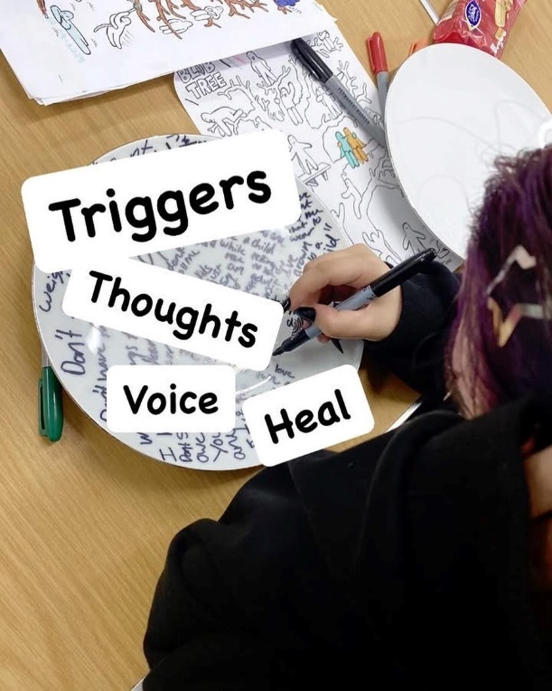
YR 2 Activity Delivered:

Shine Bright has provided the following support to young communities this year:

- An ongoing peer support group for those Teens supported in YR 1 WRAP to continue in support. 16 young people regularly attend this bi-weekly support group throughout the year.

- A 12-week WRAP programme was established focusing on those pupils transitioning from primary to YR7 in secondary schools, who may find the transition difficult and would need support to build friendships, wellbeing and resilience to prevent a decline in their mental health. Families, professionals and the individuals identified themselves as in need of this support leading to their referral. This group engaged 10, 10-11yr olds in support, with 8 completing the WRAP programme and 7 moving into the ongoing peer support provided by Shine Bright in the next year.

‘A support group that helps to prepare children for high school with continued support is something not offered by any other service and is a vital resource for young people, especially with the current mental health epidemic with young people. Parent

- Shine Bright was asked to provide a WRAP programme for a third sector org – LS14 Trust - Fall Into Place project, covering Seacroft. This mental health offer was attached to a NEET programme they were running. 8, 15-21yr olds engaged in support with 4 completing the WRAP programme. Ongoing peer support is provided by ‘Fall Into Place’ and 2 individuals have engaged with Shine Bright’s continued support offer post WRAP.

- Shine Bright was asked to provide a WRAP programme for a third sector org - St Lukes Cares for their girls wellbeing group – ‘Shine’ based in Beeston. 11, 13-18yr olds engaged in support with 9 completing the WRAP programme. Ongoing peer support is provided by St Lukes Cares.

- Learning from the successful engagement of young adults in Year 2 WRAPS and unsuccessful attempts to attract referrals and engage participants in Transition WRAP groups in YR1 helped inform an engagement plan for future transitions WRAPs. This led to securing Transforming Mental Health Funding Round 2.

Details of WRAP group attendance:

In total 45 children/young people/ young adults were supported in groups and 1:1 session’s by Shine Bright’s WRAP in YR2. Shine Bright had direct contact and impact on 27 parents and carers, linked to the participants.

This breaks down to 29 children, young people and young adults engaged with the Junior, Teens and Transitions WRAP Group 12-week programmes and 16 young people/ young adults engaged in the ongoing peer support provision, post WRAP programme.

In total (45+27) 72 individuals benefited directly from the WRAP support.
Of the 29 children young people and young adults referred and who attended the 12-week WRAP programme, 21 completed their WRAP course. Therefore beginning and end outcome data was sourced from 21 out of 29 participants completing WRAP.

Additional to Quantative data, Qualitative data has also been sourced from the 21 participants plus the additional 16, in the post WRAP peer support.

Demographic Breakdown: 45 children/young people/young adults

Gender
Male = 14, Female = 27, Transgender = 1, Non-Binary = 3
= Groups accessible to all. Retention of Males in wellbeing model proves more difficult as expected. Explored in report further.

Ethnicity

White British = 34
White/Other = 6
Black / Caribbean = 2
Asian/Other = 1
Mixed Black Caribbean = 1
Black African = 1
= engaged 75% White British, 25% diverse communities

Age

10 = 3
11 = 7,
13 = 3
14 = 2
15 = 4
16 = 6
17 = 14
18 = 3
21 = 2
22 = 1

= supported from 10-22yrs old in YR2.

Postcode

Ls3 = 1
LS6 = 10
LS7 = 5
LS8 = 2
LS9 = 1
LS10 = 5
LS11 = 6
LS12 = 1
Ls13 = 2
LS14 x 8
LS15 X 1
LS16 = 2

LS17 X 1

= support offered city wide.

Needs of our young communities
A Survey Monkey Evaluation conducted with the children, young people and families that we have supported this year, enabled us to identify their needs coming out of Covid, Lockdown and Cost of Living Crisis. We received 22 responses from parent/ carers, Juniors. They told us:

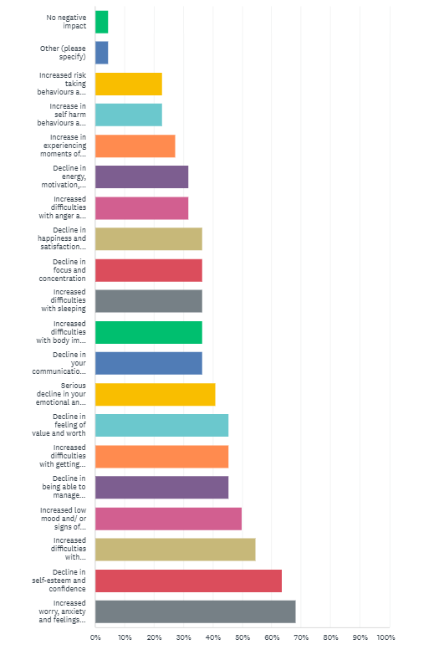
Q. We are still feeling the after-effects of Covid, lockdown and now a cost-of-living crisis. What
impact has this had upon your health and wellbeing? (Your child’s if answering as parent/carer)?

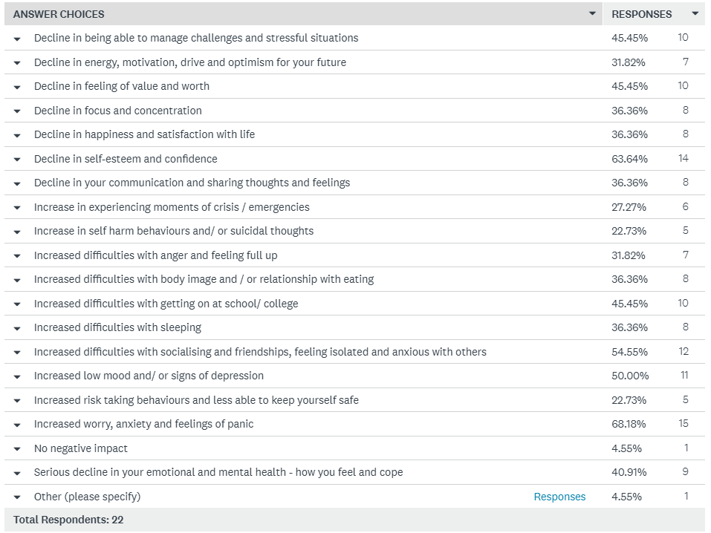

As can be seen across the 20 highlighted areas, there has been significant impact on our young communities lives holistically since Covid, Lockdown and now the Cost-of-Living Crisis. Shine Bright’s participants tell us that it has impacted their feelings of:
- Worry, Anxiety and Panic the most at (68%) closely followed by
- a decline in Self-esteem and confidence (64%) ,
- Emotional and mental health, Social skills, friendships, feeling isolated and anxious with others (55%) and
- Low mood/ signs of depression (50%)
Also significantly negatively impacted are feelings of value and worth (45%), education (45%), ability to manage challenges and stressful situations (45%) and serious decline in how they feel and cope (41%).
Other areas of energy, motivation, body image, managing crisis, anger, risk taking, self-harm, happiness, optimism, focus, sleep have also been significantly harmed.
Shine Bright believe the WRAP - Peer Support and Recovery model does support communities with all of these highlighted areas and where needed can aid their engagement into specialist services, support them whilst on wating lists, or coming out of services in order to prevent them from falling through gaps.

Outcome Measures used to evidence impact of WRAP:

Shine Bright, WRAP programme utilises two scales to evidence its impact, these are the evidenced based outcome measures The Warwick-Edinburgh Mental Wellbeing Scale (WEMWBS) and Goal Based Outcomes (GBO). These scales run alongside traditional qualitative group and service satisfaction evaluation tools. The young people at Session 1 and 12 are asked to complete these measures. The scales, measure changes in wellness due to a therapeutic intervention and map out personalised goal setting and attainment and next steps.

29 children, young people and young adults completed one initial WEMWBS and GBO measure, due to not completing the programme in full. 21 young people attending the 12-week programmes completed two measures, beginning and end. The reason some participants did not complete the programme were due to them experiencing severe anxiety and/or mental health crisis, low self-esteem and lack of ability to socialise with peers and be present in a group setting, chaotic and unstable life situations interrupting their engagement, difficulty in being comfortable and ready to address their wellness and mental health topic, barriers from society, toxic masculinity and stigma to engage in the mental health topic. These individuals did engage in several groups, and we hope they did gain from the experience. Shine Bright is here in the future if these young people decide to take up support again. We do maintain contact, to present new offers of support to those individuals that consent for this to happen.

We can see from the below evidence that the impact of the WRAP model in YR 2 is again overwhelmingly positive on an individuals’ wellness and personalised goals, metal health and prevention from crisis.
The goal-based outcomes (GBO) tool is a simple and effective method to measure progress and outcomes of an intervention. It can be used in any setting, which is change-focused and goal-oriented and helps all parties to understand whether the intervention is helping young people make progress towards the things that they really want help with.
Using the Goals Based Outcomes, young people outlined that the purpose of attending the WRAP group was to achieve their personalised goals, that fit into the below themes:

- Improve Relationship skills
- Improve Communication Skills
- Managing Feelings and improve ability to cope
- Improve Confidence and Self Esteem

Once a goal has been set (column 1 below) the next step is to gain the initial (time 1 or baseline) rating out of 0 - 10 for the goal (column 2 below). 0 represents ‘Goal not met at all’, 10 represents ‘Goal fully met’ and 5 is ‘halfway to reaching the goal’. Young people can set up to 3 goals with this measure. By collecting a follow up measure, Time 2 (T2 in column 3 below), the distance travelled towards achieving that goal can be evidenced (column 4 and 5 below). T2 was measured at Session 12 for the WRAP programme

Goals Outcomes Results from 21 participants:
Goal Set by Young Person | T1  Initial score | T2  Final score | Total change  (T1-T2) | % improvement + / decline -

Managing Feelings and Improve Ability to Cope

Learn to live a healthy life without medication 4 10 6 +60%
To control my anger/emotions 3 5 2 +20%
Keep calm in heated situations 3 7 4 +40%
Mental health getting better 3 8 5 +50%
Get better with self-harm 5 9 4 +40%
To learn better coping mechanisms 0 6 6 +60%
To learn how to keep well 7 9 2 +20%
Being able to develop the skills to help others 5 8 3 +30%
To be happier 6 9 3 +30%
To be able to understand different emotional 5 8 2 +20%
and be able to control them

To be happy 8 9 1 +10%
Goal Set by Young Person | T1  Initial score | T2  Final score | Total change  (T1-T2) | % improvement + / decline -

To Improve Confidence and Self Esteem
Learn to be more confident and respectful 4 8 4 +40%
and mindful of others.

Getting more confident 1 6 5 +50%
To improve confidence 2 6 4 +40%
To be more confident 5 7 2 +20%
To be more confident 4 6 2 +20%
To be more confident 4 7 3 +30%

To Improve Relationship, Social and Communication skills
Be able to talk to people easier 4 9 5 +50%
To become more confident/ social with 3 7 4 +40%
people
Stop being awkward 1 8 7 +70%
To be loved 3 9 6 +60%
To feel more social 8 9 1 +10%
Making friends in the group 8 10 2 +20%
Socialising and talking to others 4 5 1 +10%
I want to make more friends 7 8 1 +10%
To make more friends 2 5 3 +30%
To join a fun group and to make new friends 8 10 2 +20%
Get more friends 5 8 3 +30%
To talk to new people 6 9 3 +30%
Making new friends 9 10 1 +10%
Hope for people to like me 7 9 2 +20%
To participate and achieve for self
To come out of my house to come to group 5 9 4 +40%
To go outside more 2 4 2 +20%
To have fun with everyone in the group 9 10 1 +10%
To get the confidence to publish poetry 2 6 4 +40%
To go to college 0 3 3 +30%
To see a bright future for myself 2 6 4 +40%
To do extra things outside college 9 10 1 +10%
Not to be worried about starting school 7 9 2 +20%
To help me move into high school 7 10 3 +30%

What the data tells us:

We can see that within 12 weeks exposure to the WRAP programme, young people:

- Improved from 10% - 60% in ‘Managing Feelings and Improving the Ability to Cope’ Goals. The mean average being 35% improvement after 12 weeks.

- Improved from 20% - 50% in their ‘Confidence and Self Esteem’ goals. The mean average being 33% improvement after 12 weeks.

- Improved from 10% - 70% in their ‘Relationship, Social and Communication Skills’ goals. The mean average being 29% improvement after 12 weeks.

- Improved from 10% - 40% in wanting to ‘Participate and Achieve’ in something for themselves. The mean average being 27% improvement after 12 weeks.

The Goals Based Outcome (GB0) measures in YR2 show an improvement on all goals set by participants after 12 weeks , ranging from 10%-70% and the average mean of the 39 goals set 32% improvement. There are no decline in scores, WRAP has a 100% improvement rate on goals
The young people have further opportunity to continue to work on these goals with Shine Bright as they are invited to an ongoing Peer Support Group for all WRAPped individuals, for an unlimited period. Where Shine Bright has WRAPped participants for another organisation it has been agreed that this organisation will provide ongoing support. GBO demonstrates that WRAP is an effective change focused and goal orientated intervention.
WEMWBS
The Warwick-Edinburgh Mental Wellbeing Scale (WEMWBS)

WHAT IS WEMWBS?

The Warwick and Edinburgh Wellbeing Scales were developed to enable the measuring of mental wellbeing in the general population and the evaluation of project and programmes that aim to improve mental wellbeing. The scales support positively focused interventions, and all items inquire about positive aspects of mental health making it an accessible measure for our young people and practitioners to engage with. The 14-item scale WEMBWBS has 5 response categories, summed to provide a single score. The items are all worded positively and cover both feeling and functioning aspects of mental wellbeing.

The measure provides Shine Bright with a great deal of information to evidence the impact that WRAP can and does have on young people as part of this project. Two measures are taken as with the GBO’s, in session 1 (Time 1) and session 12 (Time 2). The total score is obtained by summing the score for each of the 14 items. The scoring range for each item is from 1 – 5 and the total score is from 14-70. Scores are collated to provide a Sum as a single number representing the level of wellbeing per individual and overall, at that point in time.

Scores can be divided into High, Average and Low mental wellbeing, as can be seen below in WEMWBS calculator detailing our real data from this project. High wellbeing is identified as a score of 60 and above, average mental wellbeing is a score of 43-59 and low is a score of 42 and below. WEMWBS ‘guide to scoring’ advise that a score of 41-44 is indicative of possible/ mild depression and a score of <41 is indicative of probable clinical depression. We do not use the measure as a clinical tool as we are a social model of early help but understanding how others interpret and use the data enables us to identify where we may need to signpost and refer on to specialist services.

“My daughter will not miss a session unless we are on holiday. She wishes they were more frequent but realises there's only so much time/funding. Family members have commented how my daughter now engages in conversation - before she would remain silent or disappear to her room. We have seen small displays of increased confidence & signs of independence.” Parent
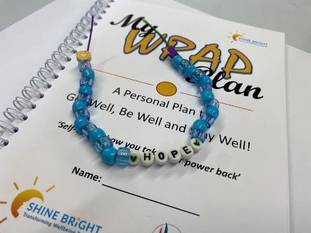

NB: 21 young people’s data was analysed as they had T1 and T2 data that can demonstrate impact and change. 8 young people that completed T1 data only, have been omitted from the score chart below.
 |  |  | Before intervention | After intervention | Change | Positive change? | Statistically significant change? | Wilcoxon signed rank test P value
Total no. of responses |  |  | 21 | 21
% Low wellbeing |  |  | 71% | 10%
% Moderate wellbeing |  |  | 29% | 62%
% High wellbeing |  |  | 0% | 29%
Mean score |  |  | 39.1 | 55 | 16.33 | Yes | Yes | p<0.05
Standard deviation |  |  | 9.7 | 7.8 | 7.7
 | 10-12 |  | 44.6 | 57.9 | 13.25 | Yes
By age | 13-15 |  | 35.4 | 51.7 | 16.29 | Yes
 | 16-24 |  | 36.0 | 56.5 | 20.50 | Yes
By gender | Male |  | 49.8 | 64.0 | 14.25 | Yes
 | Female |  | 36.6 | 53.4 | 16.82 | Yes
Number of people with a meaningful positive change (%) |  |  |  |  |  | 21 | 100.0 | %
Number of people with a meaningful negative change (%) |  |  |  |  |  | 0 | 0.0 | %

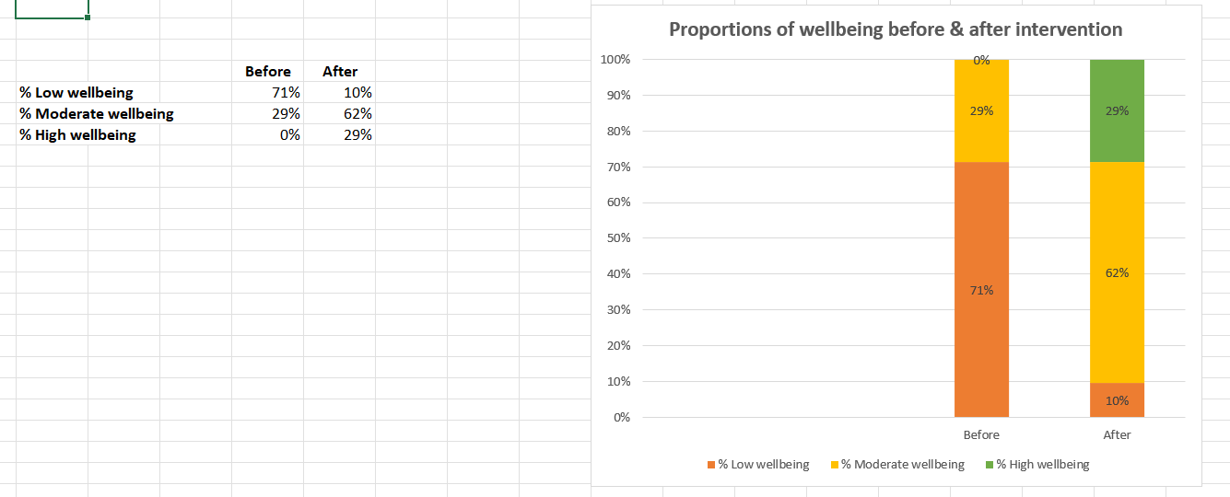
What the WEMWBS data tells us:

Before the WRAP programme young people’s mental wellbeing was - 71% Low, 29% Moderate and 0% High.

After the 12-week WRAP programme young people’s mental wellbeing is – 10% Low, 62% Moderate and 29% High. This evidences that the WRAP programme has had an overall positive impact upon young people’s mental wellbeing.

We can see:
- A decrease of 61% of low mental wellbeing experienced.
- An increase of 33% moving into moderate mental wellbeing from low and
- 29% of our young people moving into experiencing high mental wellbeing, which they attribute to completing the WRAP programme.

NB: High Mental Wellbeing is identified as a score of 60 and above, Moderate Mental Wellbeing is a score of 43-59 and Low Mental Wellbeing is a score of 42 and below.

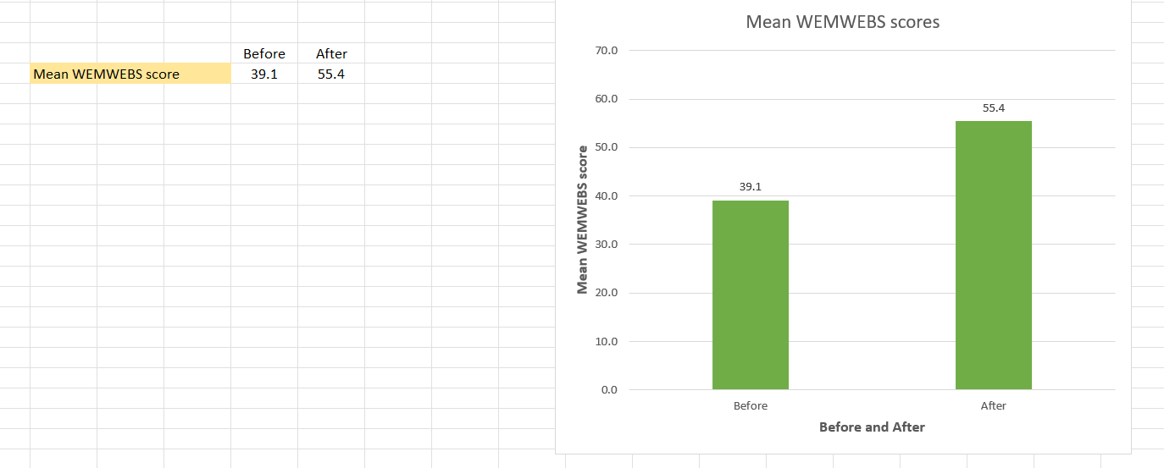
The mean impact of the project overall
The mean mental wellbeing score before the WRAP intervention was 39.1. This can be seen to fall within the Low Mental Wellbeing region and even according to WEMWBS guidance ‘a score of <41 is indicative of probable clinical depression’. We surmise that the young people attending and completing the WRAP programme demonstrate a need for mental wellbeing intervention that can both improve their mental health but also prevent their crisis. 14 were initially seen to score under <41, after the WRAP programme only 2 remained in this region.

After the WRAP intervention the mean mental wellbeing score is 55.4 seeing a 16.3 mean improvement/change. 55.4 falls just above midway in the Moderate Mental Wellbeing score range, elevating young people far away from the clinical region for probable depression (<41) and even mild depression that some exhibited.

According to WEMWBS interpretation tools, the data shows that WRAP has a ‘positive change’ and a ‘statistically significant change’ to the mental wellbeing of 100% of these young people.

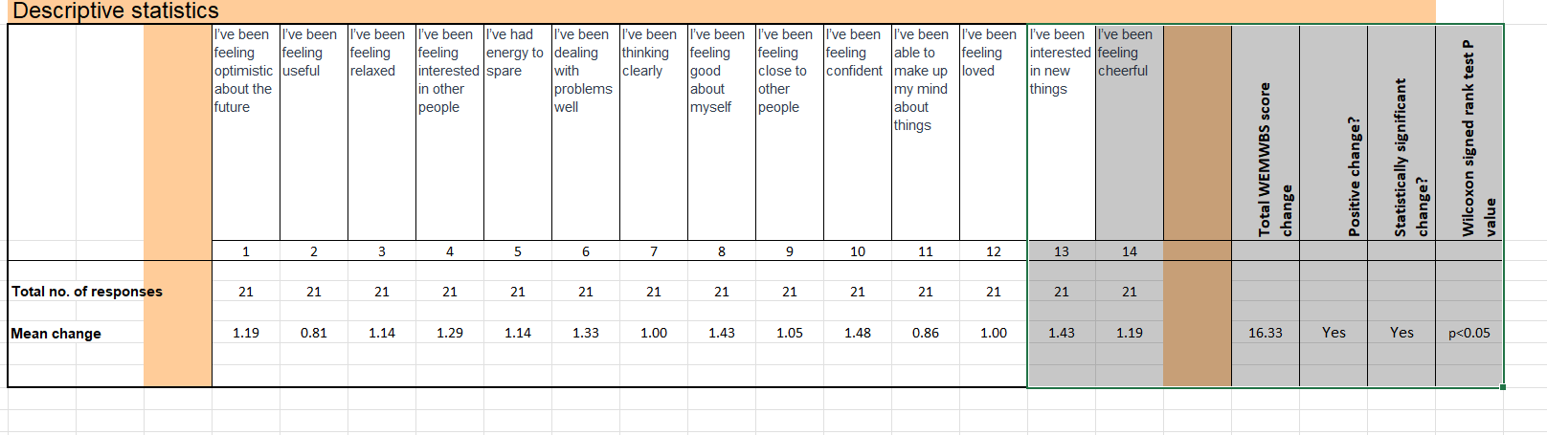
Mean change per WEMWBS rating

All scales are marked out of 1-5. On average
  - The lowest impact at mean 0.81 (16% improvement) is ‘I’ve been feeling useful’ and 0.86 (17.2% improvement) is ‘I’ve been able to make up my mind about things’
  - the greatest impact has been ‘I’ve been feeling confident’ with a mean improvement of 1.48 (29.6% improvement).
  - This is closely followed by ‘I’ve been feeling good about myself’ and ‘I’ve been interested in new things’ with a mean improvement for both of 1.43 (28.6% improvement),
  - ‘I’ve been dealing with problems well’ at 1.33 (27% improvement) and ‘ ‘I’ve been interested in other people’ 1.29 (25.8% Improvement) is great to evidence as an improvement for our young communities as they build relationships and learn new coping strategies within WRAP.

Looking at the individual scales, all 14 demonstrate a positive improvement / change for all the young people.

‘I think it’s fantastic that shine bright operates independently within local communities, it’s not affiliated to schools/education or Children social work services, it has a real grassroots approach which is relatable to young people and families. The WRAP recovery programme has supported my children to feel confident to talk about their emotions without fear of being judged, they learn fun healthy ways to manage their emotions and identify who safe adults are. The programmes helps to break down the stigma that talking about emotions is negative and a sign of weakness. Children continue to be under pressure and stress in today’s world, there is very limited access to statutory mental health support, so community groups like shine bright are vital in the fight to support our young people. In an ideal world this group should run every day of the week in multiple areas, the programme is fantastic and well thought out and planned.’ Parent

Qualitative Feedback:
Exploring other methods to measure impact of Shine Bright:
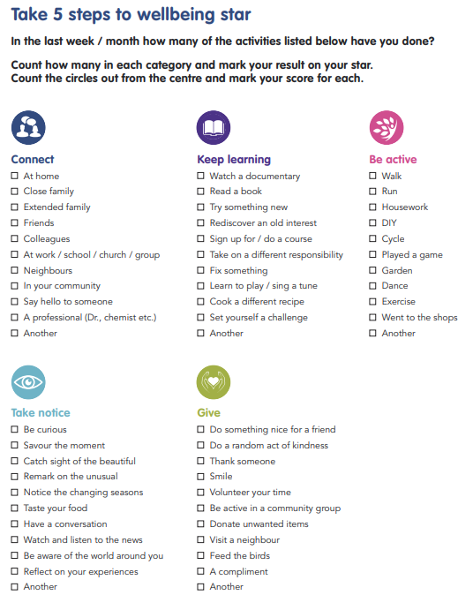
Shine Bright have investigated other outcomes to measure WRAP’s impact. We turned to the Five Steps to Wellbeing Star.
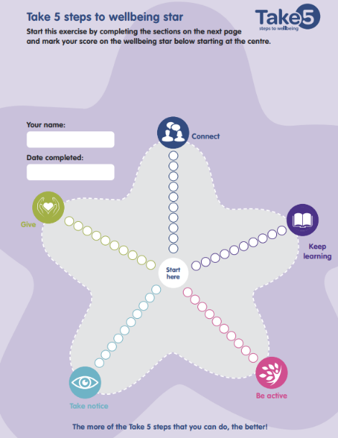
Looking at the defined checklist the peer support group who had volunteered to review the tool for Shine Bright felt that this was designed more with adults in mind rather than for young communities. They felt that not all the checklist markers for the scaling were relevant to them and their age, or written in the language they relate to such as - ‘connecting with colleagues and neighbours, watching documentary, rediscover an old interest, fixing something, DIY, garden, savour the moment, remark on the unusual, listen to the news, volunteer, donate etc.
The peer support group members stated that if they used the checklist, they ‘may never score a 10 in some areas due to how some of the points were defined.
Rather than trying to gain quantative date from the tool we liked the simplicity and design of it and attempted to evaluate the impact of WRAP in a qualitative way under the framework set out in the ‘5 steps to wellbeing’. We hoped for the future this would create our own checklist that we could devise in these areas under ‘Another’. The evaluation outlined by the groups under each step are as below:

GIVE: How has Shine bright helped you Give?
- Worked together in games
- By taking care of other people in the group
- It showed me doing random acts of kindness to strangers can make someone’s day and mine!
- Because we work as a team in everything we do!
- It has helped me to do random acts of kindness more
- It has been nice to put others first
- Amazing place to meet new people who feel the same way that I do. They help me and I can help them too.
- Shine Bright has encouraged me to grow in confidence and demonstrate vulnerability the typical cliché that it’s okay not to be okay and to open up when feeling low. Mental Health is such an issue in the UK and it needs rectifying. There is such a gap in readily available mental health support in the UK and it can be months until someone can gain support. Shine Bright fills a void in the Mental health system”
- Talking to others who are struggling
- Helped me be able to accept other people’s opinions in things even if I don’t like them myself
- To help meet others a similar age and understand and look after yourself and other people.

TAKE NOTICE: How has shine bright helped you Take Notice?
- Having a conversation with people
- To see and know that other young people have things in common with me.
- Its showed me if you are mentally well you will notice the world a lot more.
- It has helped me listen to others and pay a lot of attention to what people are telling me
- Share things in common with other groups members
- Helped me live in the present and appreciate the world around me
- Very good support, when I felt down straight away the staff came to talk to me. I was noticed.
- I benefited by being part of a group where I could share openly about my own experiences and the WRAP programme supported me to do this

ACTIVE: How has Shine Bright helped you be Active?
- It has encouraged me to practice things I would not do much
- We go outside the space and keep active and get healthier and I do dance in school. Shine bright has taught me how important it is to do this.
- It has helped me to realise if you are mentally healthy you will have a better relationship with physical activities.
- Playing drums and music
- It has encouraged me to play football more than I normally would
- I have seen that I have begun to play football a bit more now I am feeling better
- It has helped me to understand that looking after my body and drinking enough water can help me be well.
- Have taken up rugby and been going to the gym…..also making efforts to improve …diet
- Groups are entertaining and something I look forward to going to.
- Undertaking physical activities that demonstrate tools to stay well. This creative way to explore mental health helps us understand the message in a deeper way.

KEEP LEARNING: How has Shine Bright helped you to Keep Learning?
- WRAP is a well thought out group that focuses on my own personal wellbeing journey
- I learned that I am a nice person
- A space to learn how to manage feelings
- Learn how to help yourself in tricky times
- Thankyou Shine Bright for supporting me through thick and thin for the past year. You have caused me to realise that being negative gets me nowhere, that life can get better, that I can be resilient and to overall just try my best and be kind to myself.
- I have learnt that I can have loads of confidence in talking to people about my mental health
- How to look after myself properly
- The activities in the group have taught me how to protect myself
- I have learnt to accept myself and learnt how to make friends
- Taught me different strategies and wellness tools to help myself
- It has taught me how to make myself feel better if I am sad or angry
- Shine Bright has helped me to learn new things through the activities and discussions we have
- It has helped me learn how to control my emotions by allowing me to talk about them in a safe place
- Shine Bright has taught me how to become a more confident person as I have become more comfortable with myself.
- What I have learnt has been the best thing, I have new coping strategies
- The WRAP programme helps young people to understand themselves better, to create a personal plan for themselves and manage their own mental health and wellbeing
- The group is welcoming, supportive and helpful when thinking about how to manage your own mental health/wellbeing.
- I have come a long way with the group and changed how I think about myself.
- They have helped me be able to be certain about my boundaries and put myself first. I now know it is not selfish to put energy into looking after myself.
- I learned a lot about how to calm myself in certain situations
- The activities like save the egg or blasting triggers with nerf guns were fun but also got the message across
- Games, team building, learning about WRAP in different ways
- The group is very supportive with lots of good ideas and activities linked to WRAP

CONNECT: How has Shine Bright helped you Build Connections?
- By making it easier to make new friends and meet new people
- It helped me to be more confident with other people
- Helped me find techniques to talk to other people
- They helped me by being able to create connections my helping me feel better about doing this
- Shine Bright made it easier to make new friends and meet new people
- Shine Bright has helped me build connections because I have made new friends.
- I came to the group because I had the chance to be with people like me and I took it!
- Shine Bright has helped me develop my social skills and had made me more comfortable with others. It has built my confidence in myself. I am very anxious but I feel safe with the people here.
- Shine bright has helped me in a positive way by supporting me with friendships. The group made me bond with new people and showed me that other people are struggling too.
- Shine Bright has helped me develop my social skills and has made me more comfortable with others.
- I had the opportunity to ask for and receive support.
- It takes people out of the outside world into a space where they can learn ways to cope with issues.
- The ongoing support through the additional peer support groups helps me to continue to work on my WRAP Plan and adapt it to suit me at every point in life and for new situations.
- How to communicate better with people my age
- It’s okay to feel down and the group has helped me know how to control my emotions.
- Being listened to, not feeling different or less than!
- Feeling more confident about opening up and talking to others.
- Never felt judged for expressing myself
- Learning the wellness tools was helpful
- How to identify and manage stressors and triggers in a healthy way
- What to do if your sad and depressed
- How to manage situations better and manage if I am in a crisis
- I learnt that one day you can be at the place you always wanted to be. WRAP helps me achieve this.
- I learnt not to give up on myself
- Be patient, sometimes you have to go through the worst to get to the best
- What WRAP means and how to deal with how I feel about my Grandad’s death
- I learnt to work on being in love with the person in the mirror who has been through so much but is still standing.
- I learnt that I am enough
- I learnt not to give up on myself
- WRAP has help me a lot to make new friends, the people are really nice to me, 10/10.
- I like coming to the group because I get laughs and smiles
- I love coming to the group because I have made myself a group of friends.
- I have enjoyed being able to come to a group and make new friends and have fun.
- Shine Bright has helped me build my confidence and become more comfortable around other people.
- Shine Bright has helped me with lots of things, its helped me with being more confident amongst people and given me people I can connect with and talk to. It helps me with feeling better about myself.’
- Shine Bright has helped me in many ways, starting off with being able to speak about my feelings without feeling judged. I am able to hang out with and talk to people who relate to me.
- Shine Bright has improved my confidence, in speaking in crowds. It has also helped me speak about how I’m feeling, when I’m feeling good or bad
- Shine Bright has developed my social skills and made me a better person, it helps me to cope with the daily stresses of school and life
- My time at Shine Bright has really helped me with my confidence and it helped me gain lifelong friends. Coming to the group has improved my social skills and peaked my mental health so much! I love attending the groups.
Shine Bright provides evidence above that it impacts positively on children, young people and young adults mental wellbeing in all 5 of the steps to wellbeing – Give, Take Notice, Active, Keep Learning and Connect. Shine Brights impact is demonstrated more in particular areas, such as the Keep Learning and Connections which mirrors the intention of the WRAP model to develop experts of themselves and build protective factors and supporters around the individuals. The Five Steps model shines a light on areas we could do more with, such as; more opportunity for them to recognise how they Give to each other in the groups and the role they play as peer supporters, How we address Active and the correlation between physical and mental health more effectively and finally Taking Notice which encourages Shine Bright to think about trips out, experiencing the world them and supporting them to be able to venture out at their own pace. Shine Bright will continue to evaluate the impact of support under each step and adapt practice accordingly.
Service Satisfaction Evaluation

Shine Bright sends out a service satisfaction questionnaire via Survey Monkey to the children, young people and families that we have supported within each project. We received 22 responses from parent/ carers, Juniors, Teens and Transitions for the Trauma informed project. This link was sent to their phones and emails.
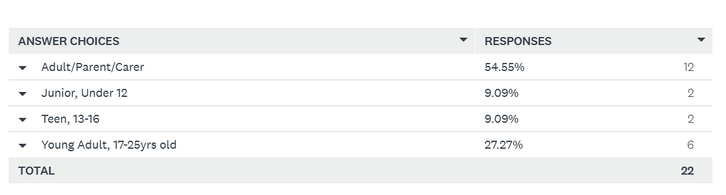
The highest return rate comes from Parents and Carers at 12 responses and Young adults at 6. We can see engaging the younger age ranges in evaluation proves better undertaken face to face, to receive a higher response rate. Qualitative feedback gained from children, young people and young adults throughout the report has mainly been sourced via face-to-face group sessions, outcomes meetings and individual interviews.

Below are the responses received from the online evaluation:
Q. Had you or your family looked for or tried other support before finding the WRAP service? If so, what support had you considered and what made you choose the WRAP service as an option now?
- We had support from Mindmate but that was just for a short period, not ongoing
- Yes, we asked at my previous school but received little to no support
- Yes, a lot of clinic service, CBT, psychotherapy, exposure therapy, hypnotherapy.
- Had considered discussions with school but felt like the WRAP service might be a better starting point. Have since approached school for additional support and been on the referral waiting list for 12mths.
- We were considering applying for support from CAMHS but had heard so many nightmares about long wait times and needed help quickly. Once we started at Shine Bright, we felt CAMHS wasn’t needed.
- No. I chose the WRAP because it was highly suggested by my doctor
- Yes, I have numerous other supports. Main reason was drawn to service was learning strategies to cope and manage my mental health
- Other support was not working for our child.
- Originally, I saw the advert on Facebook for a support group for Teens who had been affected by the pandemic. I went through a divorce during the pandemic and we had two family bereavements - my son’s temper and moods were bad due to the stress of all the sudden change. The advert for the group was warm and friendly rather than clinical or formal so I asked for my son to join. As he got older, he went into the ongoing peer support group and has learnt invaluable lessons about how to handle his anger and emotions. The group gave him peer support and friends at a time when he didn’t have any. The leaders of the group are kind, sensitive and dedicated to helping others. Can’t thank them enough for everything they do for him and the other group members

- 12mths ago, we made an autism referral via school. We are on the waiting list but have not followed this up with 'right to choose' as we feel she is coping better with Shine Bright support.
- The group have provided support that has meant my son doesn’t need to go to the doctors about anxiety etc.

Q. How easy was it to access the WRAP support? (e.g. hearing about it, first contact, information provided, drop-in, sessions with the group)? What worked, what did not work? Please do suggest any improvements that we can make.
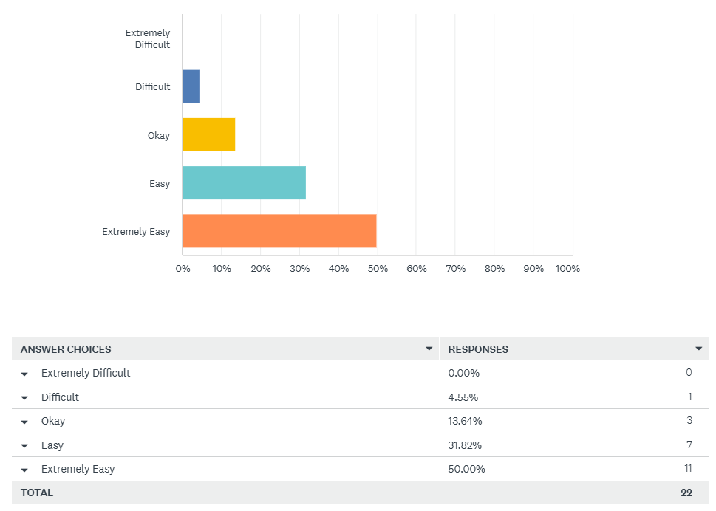
82% found accessing Shine Bright - WRAP support Extremely Easy and Easy. Below individuals tell us their experience of accessing the service. We have underlined the feedback that evidences the trauma informed approach adopted by Shine Bright, in its efforts to engage communities.
- A message was shared on a school WhatsApp group, I got in touch with Nicola and found out all the info I needed
- My mum saw an advert for it and got in touch to arrange a trial session and I started attending soon after
- I only found out about it through social media
- It was quick and easy to start, no pressure and there’s support to get me ready and comfortable to join the group in my own time
- Sent a message to Nicola after seeing Shine Bright recommended by a friend on Facebook. I didn't know if it would be right for my daughter but had nothing to lose. We met in a cafe before the programme started. Nicola explained the WRAP service in more detail and made my daughter feel there was no pressure to take part. It was purely her decision. At the first session, I could stay as long as required but didn't need to stay long as my daughter settled in quickly. Although she was quiet & nervous, I think she realised how the group had lots in common.
- I was put into the program against my will after I said no but I’m glad they did; there’s always someone available to talk to. (This was not forced by Shine Bright, parents or referrer may have applied this pressure without Shine Bright’s knowledge).
- I had a connection towards the group so was introduced through mutuals
- I saw a post on Facebook and privately messaged the organiser. She replied quickly with lots of information, and supportive advice and we immediately felt listened to and understood at a very dark time.
- Both my children have attended the WRAP group at different times, on both occasions Nicola advised the group of community groups and social media, she responded to my initial request for information promptly, she keeps in weekly contact with parents/carers and completes consent forms with emergency details/medical info
- Excellent communication from Nicola
- Nicola made it so very easy for us - so straightforward and Nicola was always there if anything was unclear regarding referral form etc.
- Because I knew what to expect from WRAP and I was able to visit the spaces.
- Very close to the worker and was very easy to participate
- The hard part was hearing about the service. I didn’t know it was a thing at first but everything else was easy to access and join. Wish it was more out there so people knew it was an option
- Through a friend, my young lady really enjoys going! And has never missed a group. She has made some good friends through going.
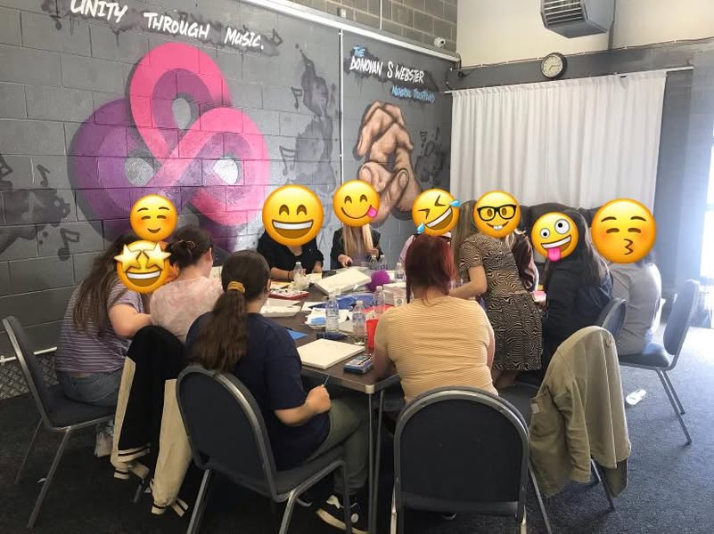
- Good communication throughout the joining process.
- Nicola she’s so kind friendly and encouraging

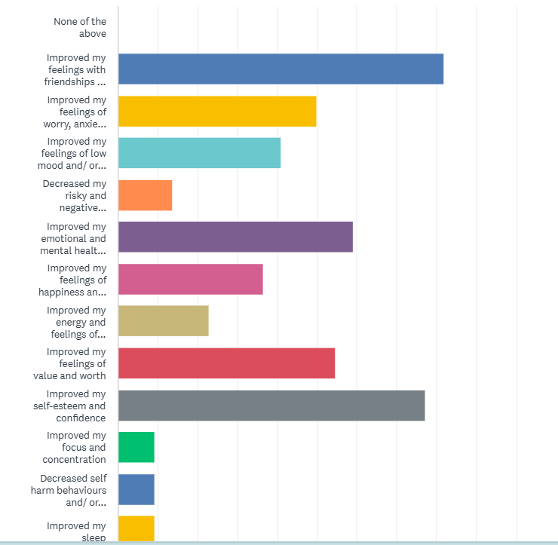
Q. Has Shine Bright and the WRAP programme helped your health and wellbeing so far, (Your child's health and wellbeing if you are answering as a parent)? If so, please tick how the support has helped you

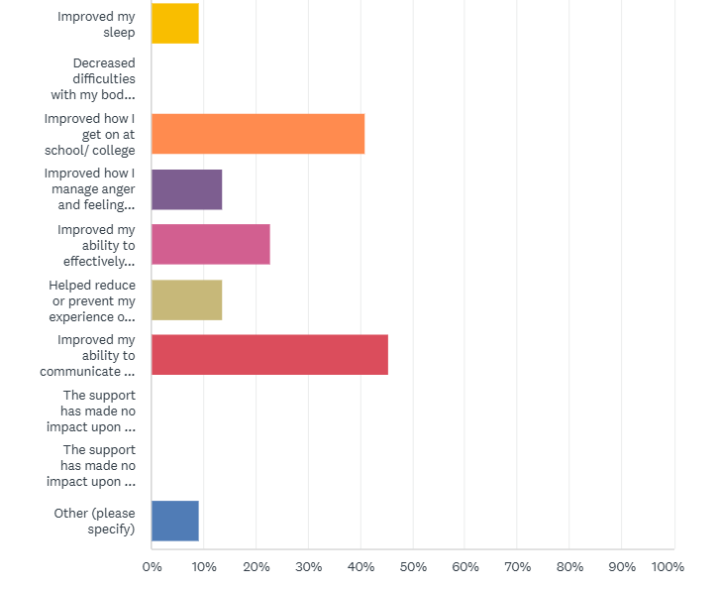
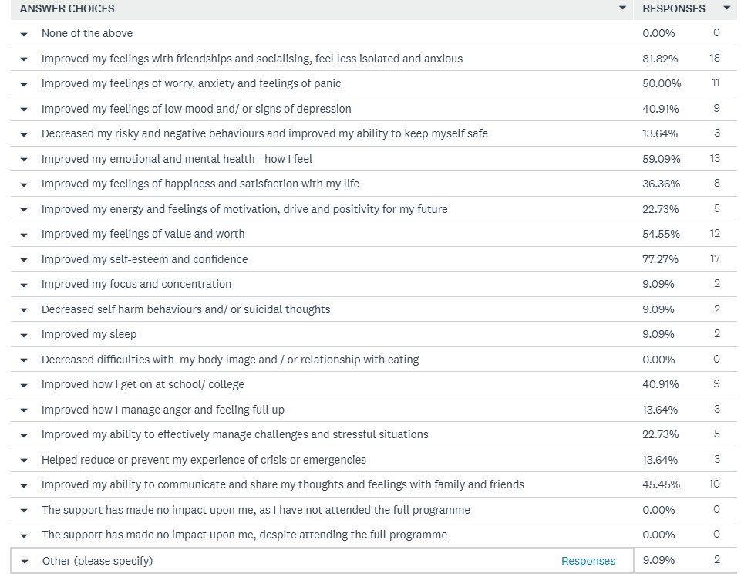
- ‘It has made me be able to speak a lot more in bigger groups, about sharing how I feel about a number of different problems’
- ‘I can express myself'

As can be seen across the 22 highlighted areas, Shine Bright’s WRAP interventions can be seen to have a significantly positive impact on those areas highlighted by participants as the most damaged due to Covid, lockdown and cost of living crisis. Through participation in Shine Bright’s WRAP offer our young communities benefit:
- friendships, social skills and related anxieties and feelings of isolation are considerably improved at 82%.
- participants self- esteem and confidence improves (77%) as does their
- emotional and mental health – how they feel and cope (59%).
- self-worth and value (55%),
- feelings of worry, anxiety and panic (50%) closely followed by
- ability to communicate and share thoughts and feelings with others (45%).
The WRAP - Peer Support and Recovery model does support communities significantly and due to the ongoing peer support, offers this impact in a sustained and protected manner that has impact long term, even lifelong due to their personalised WRAP Plan, training and volunteering, employment opportunities.

Shine Bright moving forward will pay close attention to the areas where there has been less significant impact such as; self-harm behaviours, keeping safe, sleep, anger, focus. We can introduce more coping strategies, tools and techniques in these areas, providing learning and guided conversation to improve our impact here. Shine Bright will be mindful of this learning for future delivery.
In contrast to this digital feedback, reviewing the face-to-face feedback from young people, detailed within the rest of the report, we are told that we do have impact in these areas.

Q. Please tell us what you think the most helpful thing about Shine Bright and WRAP is so far? What is helpful and less helpful for you?
Helpful:
- My son has really enjoyed the group, he finds it helpful, he feels valued and listened to and it has improved his confidence. He is happy that the group is quite small.
- The best thing is that you get to make so many new great friendships and support each other
- Being able to talk to other teenagers that are going through the same things as my daughter
- Helpful - the group getting out seeing other people creating a safe space.
- being able to fully express myself and tell the group how I’m feeling openly.
- Meeting new people and coming to an understanding of our emotions together
- Its helped me be more open about myself. Being able to try to talk about issues I have.
- Being able to have a conversation about feelings in a group of people.
- For us the friendships and peer support from the group has been life changing. As a parent we can support our children and give reassurance, but it’s not as powerful as coming from peers. WRAP really helped my son feel less alone and feel part of a community. He was ostracised and bullied at school and his self-esteem was on the floor. He is a different child now, he’s confident and kind and keen to give back and show support for others. I’m very proud of him and will be forever grateful to Nicola and team and all the kids at Shine Bright.
- The most helpful part of being a member of the WRAP group is that my daughter has learnt healthy coping strategies to manage and maintain a positive mental health and well being
- I can see an immediate improvement as soon as she comes out/ arrives home. It gives her the essential emotional top up she needs. Incredibly grateful too for the assistance we have received in getting her to the group on those weeks when due to work it would have otherwise been impossible
- Knowing people from my school like me
- Making new friends. Being able to share about my day and feelings.
- An extremely positive group which allows my daughter to open up, be herself and express herself. Keep in touch with friends, share ideas. Nicola is approachable and my daughter can talk to her about lots of issues and she is very caring. It has helped immensely with my daughter's mental health and self-esteem.
- Being able to do blob trees at the beginning is something that I think works really well in the groups as we get to know what has been going on and if anything needs to be talked about to help fix a situation. The tasks are always fun and the snacks are good as well.
- It has been great
- I like the structure and learning the strategies like wellness box or identifying triggers.
- Talking to other like-minded youngsters has helped her enormously.
- The group is great - they can get messages across to my son that he won’t listen to from me, as his parent.
- Discussing problems with peers from same age group in a safe environment
Less helpful and could be improved:
- I don’t like talking in front of people I don’t know so it’s scary.
- Not helpful – the directness of topics.
- What doesn’t always help sometimes is the fact it’s a group and it would be nice to talk to someone 1to1 sometimes so your problems have full concentration
- Would like a few more drop-in sessions before starting because at first it was only a few people so I felt more awkward
- I wish the group had the funding to meet weekly.
Q. Please provide a short sentence/ case study that explains how Shine Bright and the WRAP group has helped.
- It has made me feel more positive about life knowing I have a strong support system and friendships
- Shine Bright has helped build my confidence and helped with my anxiety. I have had advice and strategies to help me cope.
- WRAP gives people a chance to focus on themselves in a way that suits them and with workers who can dedicate time and one to one support
- My daughter can't imagine not coming to Shine Bright/WRAP. Our whole family hopes this service continues as long as she needs it. When she's feeling stressed, she knows the check-in sessions aren't too far away so it helps her get through. Her sleep seems to have improved and this can only help her function better during the day. Our family & friends have noticed improvements too - many saying that she's come out of her shell and can more easily hold a conversation. She definitely spends less time in her room. I would 100% recommend WRAP service to a friend (in fact I have several times). I feel it empowers young people & they learn life-long skills for wellbeing & self-care.
- It has helped me get out of bed and out of the house for a few hours which helps my mental health significantly
- It has helped with a lot for me and I’ve been supported through a tough period in my life and I think other people deserve support like I have
- My son was struggling with his sense of self-worth after being bullied at school. WRAP helped him establish a friendship group and feel part of the community. He had been scared to go out of the house and felt alone in the world and bullied and ridiculed at school. He came out of school and the support from Shine bright helped us to heal and now my son has successfully re- entered education.
- Shine Bright has helped me by making me feel more comfortable to talk to people my own age and older. I have been a member of the groups for almost 3 years now and have loved every second of it. The people are all really nice and I enjoy getting to hear about what everyone has been up to.
- As young people reach adulthood there can be an abrupt decline in support. The WRAP group has helped with the transition from CAMHS to adult services
- Can’t thank you enough. The reassurance it provides is immense. There are so few options of support for our young people. This group is invaluable.
- Being at shine bright has really helped me to step out of my comfort zone and talk to new people.
- It has improved my mental well being
- The best things is that my brother has made new friends when going into high school and I have made new friends too for when I move into high school. I am now excited about going into high school rather than worrying about high school.
- Shine Bright has helped my daughter to keep in touch with her friends and make new ones. This is important as she struggles with friendships and often feels left out and isolated. Shine Bright helps my daughter to feel valued and has boosted her self-esteem and confidence. My daughter is vulnerable and the group has helped her to feel part of a group where she can grow as a person and be herself. My daughter is often vulnerable to being bullied at school and this group has helped her to deal with tricky situations and valued. It is important for my daughter to continue with Shine Bright, to help her to deal with ongoing issues of growing up and conflict in school from other children.
- If I didn’t have WRAP I would be more isolated and feel worse than I do now
- My young lady and other young people I know would be so upset if they were not to go! My young lady really loves this group.
- This is the best group for this age group to open up about concerns & feel safe and the staff are amazing, the kids feel safe there.

Q. Please rate your overall experience with the Shine Bright Service / would you recommend us to others?
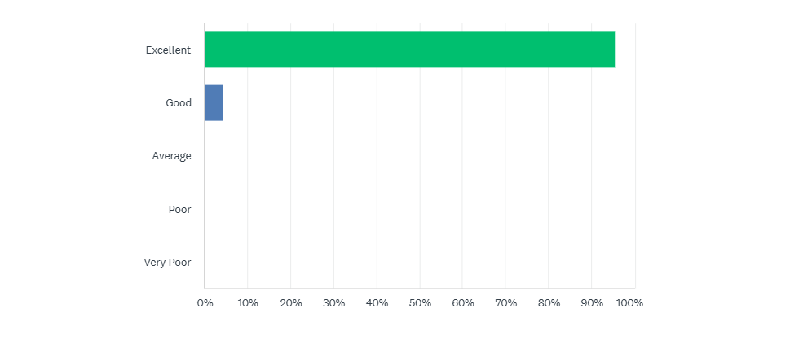
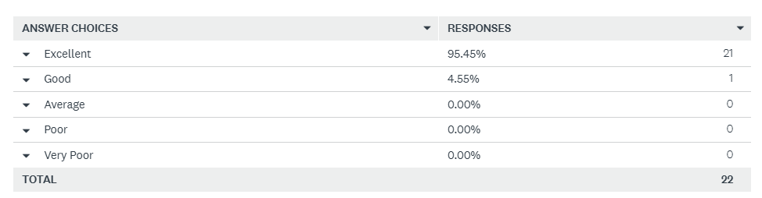
100% of participants feel that their experience of support from Shine Bright is ‘Excellent’ to ‘Good’ and 100% would recommend the service to others
- It has made me feel so much better about things and I look forward to whenever the group meets up
- You're wonderful! So glad we found Shine Bright
- I have loved all of it, making a little community between us all, have a catch up for the first 30min-1hr. Feeling a part of a family. Everyone’s welcoming and warm towards you
- Shine Bright has been a lifeline for us - caught us when we were falling.
- Fantastic trauma informed, Systemic working. Long may it continue and grow
- Thank you, thank you, thank you for all that you do ! A lifeline to our young people.
- It has been very amazing and helped me a lot with my mental wellbeing.
- The group has helped many other people as well as me and I think it offers great support and fun activities
- I love attending the shine bright groups, I have made lifelong friends there and it has had a great impact on my mental health💗
- Feel like I am valued and cared for.
- Excellent service may shine bright continue with this excellent and very valuable service.
- Thanks to Nicola and her team for everything they do to support young people.
- The staff are fantastic …. They are so good at what they do
- Nice people which give us privacy when we need.
- Very nice and supportive to everyone in the group
- Amazing, understanding, helpful and kind
- Very supportive and flexible when struggling with my mental health and wellbeing and how to manage stress
- It has helped me so much and I will always be grateful
- Message to others - definitely do it, it genuinely helps!
- It helps you and your mental health
- It was amazing because it helped me
- WRAP was AMAZE because it was FUN
- I come to the group because it makes me mentally healthier
- WRAP can be really helpful for all young people
- Go for it, it helps more than you expect it to!
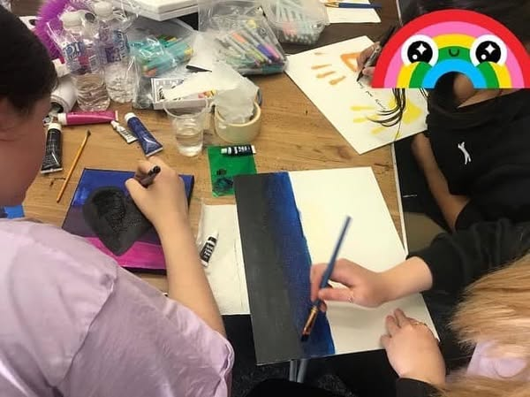

Potential Improvements to be considered from feedback sourced.
- To improve people’s awareness and knowledge that the service exists
Response: The accessibility score in feedback will increase as Shine Bright referral pathways and marketing increases across the city. As more support is resourced Shine Bright can advertise wider about how it can benefit the Leeds Communities. Strong mental health pathways from Mindmate, Mindwell, CAMHS, CAMHS Transition teams and voluntary sector have since developed.

- To have more boys in the groups
Response: Shine Bright will continue to recruit and try to retain Males in the groups. Inherent issues with stigma, toxic masculinity, societies message often that mental health is a weakness, not wanting to show a vulnerability, prevent Males from staying engaged or becoming engaged. To offer more 1:1 support to engage, more work for individuals to fully understand what WRAP is and what they are coming to. This often is a problem when Shine Bright runs a WRAP for a partner agency and they are in charge of their referrals and how they explain and sell WRAP. Shine Bright to work closer in the referral process with partner agencies.

- I don’t like talking in front of people I don’t know so it’s scary.
- The directness of topics is sometimes not helpful
Response: It’s important young people know what they are coming to. WRAP although more informal and youth based than specialist therapies does still address difficult topics such as triggers, early waring signs, decline in mental health in order to devise a wellness and crisis prevention plan. Participants need to understand what they are attending and be fully informed. Shine Bright to ensure all those attending a WRAP speak directly to the service to gain a full explanation of what to expect. More time to run drop-ins before WRAPS start to build relationships, trust and understanding in participants.

- What doesn’t always help sometimes is the fact it’s a group and it would be nice to talk to someone 1 to 1 sometimes, so your problems have full concentration
Response: individual support is offered in sessions for those that need it but cannot be offered for all or for the length of the group as this reduces the capacity of resources away from the rest of the group. 1:1 support sessions are being offered to group members away from the group for those that identify they need this. Sometimes the community space does not have an additional room to go to if someone needs to speak. To try and ensure all community spaces chosen to have adequate spaces. There are difficulties in booking community spaces due to availability.

- Would like a few more drop-in sessions before starting because at first it was only a few people so I felt more awkward
Response: Shine Bright has built in drop-in sessions for visits to the group, space and with WRAP practitioners before the groups begin. To also offer potential zoom drop-ins to enable further options for initial engagement.

- I wish the group had the funding to meet weekly.
Response: Shine Bright continues to source funding for all of its provision including the ongoing peer support element, ensuring the support is not a time limited offer.

- Shine Brights observation: 12 week WRAP programmes are heavily measured with evidenced based outcome tools – WEMWBS and GBO. The ongoing peer support element impact is not captured robustly, other than qualitative evaluation. Shine Bright, moving forward will focus on using ‘Groups Session Rating Scales’ to measure the effectiveness of the peer support element, as it is a vital piece of the support offer.
Shine Bright will also continue to explore the Five Steps to Wellbeing model , looking to develop practice in the areas of Give, Take Notice and Active and also explore an alternative checklist that represents the ‘Another’ options under each step, which are more relatable for our Young Communities.
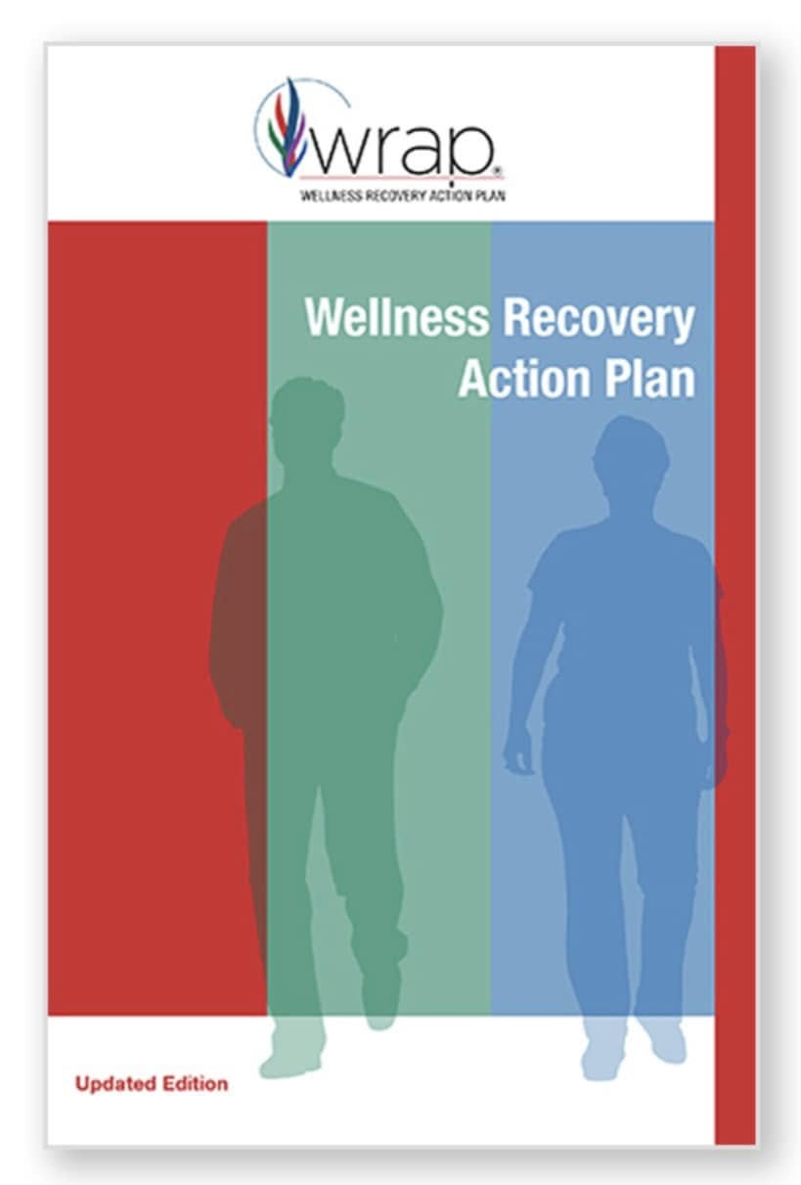

Case Studies:
Shine Bright WRAP facilitator
WRAP is something I discovered at 18yrs od when I was in mental health crisis, after having used 6 years of clinical services through CAMHS. I had anxiety, panic attacks, complex home life and at the time self-harm, my mental health was constantly up and down. I did transition to adult mental health services and didn’t like this after trying a couple of session due to the environment and some group sessions too, with much older people. It was at this time I came across WRAP and ended up trying it. WRAP is something I still use to this day 12 years on and it has helped me understand myself, notice my own trigger, early warning signs and what I need to do daily to keep myself well. My mental health has been more stable during my 20’s due to the fact I know my warning signs and I am able to create actions plans for triggers or challenges In life.
Out of this, I am WRAP trained and I have been able to deliver this to young people for many years. I love being able to give back and just helping other young people with some tools and support that is in a more relaxed environment, just learning about yourself and new tools along the way than the traditional one to one therapy doesn’t always work or doesn’t work by itself. You need the peer support element too.”

Transition Young Adult/ now a paid WRAP Facilitator, 21 yrs old
Throughout my teen years and early adulthood I struggled massively to find support that worked for me. I have been through numerous services that have only ever provided me with limited amounts of support such as 6-8 sessions, as someone who needs to build connections before opening up, this does not work….WRAP gave me the chance to explore my issues in a different way from other services with peers, through understanding triggers, spotting early warning signs and changing my mindset - WRAP taught me so much about myself and inspired me to help others. At the end of my 12-week WRAP Programme Nicola expressed that she saw something within me that will be beneficial to supporting my peers. At first, I doubted Nicola’s confidence in me but when I began the WRAP training, I realised that this is something that I would love doing, being able to alter such negative issues and perspectives in others’ lives, especially in the time of a mental health service crisis! It gives me a world of pride to be a part of an ever-evolving positive change within the mental health system. I will be forever grateful for Nicola’s confidence in my ability to help others and the support she has provided me with over the past 3 and 1/2 years.

Parent case study
Towards the end of the pandemic, I saw an advert for the Shine Bright support group.
My fourteen-year-old son, G, had been greatly affected by the disruption to his school routines, which coincided with the death of my dad and grandma and also my 20-year marriage (to his dad) ending. Due to our separation that started in June 2019, his dad went to stay in Lancashire during the pandemic and although they stayed in touch by phone, Zach missed him greatly.

Due to the problems I was facing, I wasn't able to provide enough emotional support for G and without the regular positive input from school, he really struggled. He couldn't regulate his emotions and felt a high degree of anxiety in many social situations. He also hadn't developed high school friendships when the pandemic started and so also felt lonely a lot of the time.

G started to attend the Shine Bright support group and immediately I noticed a difference in him. He looked forward to going each week and told me about the activities they did together and the friendships he was building. As he got older, he moved into the bi-weekly peer support group.

The peer support group has been great for him: he is surrounded by positive young people, with some who are slightly older than him, who are natural and positive role models. The peer support workers normalise conversations for him around health and well-being in an informal way, he is able to share his experiences with his friends at the group. He leaves each week feeling understood and accepted.

G struggles to talk to adults about his feelings (including teachers). The group is perfect for him because he gets the emotional support, he needs from his friends but also feels confident to speak to the leader when he needs to.

G told me that he has learnt anger management techniques at the group and also advice about ways to keep himself healthy. He has taken up rugby and been going to the gym. He is also making efforts to improve his diet - before he attended the group he was overeating as a comfort mechanism - he does that much less now. He has lost weight and his mental health and sleep have improved. I've noticed a positive change in his moods too. He also had the confidence to apply for a part time job and is looking forward to saving up some money for driving lessons.

In my experience. the Shine bright group provides a fun, safe and therapeutic space for young people to grow in confidence, develop healthy friendships and develop the habit of positive behaviours.

I can't thank the leader and her helpers enough for all they do to support G and other young people in the area. In my view, their work is life changing to the young people and their families in the area. As a single working parent, Shine Bright's support is crucial to the health and well-being of my family.’
Parent of ongoing Teens Peer Support Group Participant. Case study not to be used for publicity or promotion due to identifying material. Name has been anonymised. Was happy for it to be used in funding ids and with funders as evidence of impact.

Conclusion.
Trauma Informed Work in communities funding has provided Shine Bright the opportunity to further demonstrate the impact that the WRAP (Wellness Recovery Action Plan) approach can have across it’s young communities and their families. Our outcome tools show a positive impact across a range of ages 10-22yrs old, who became involved in the support within YR2.

As evidenced through WEMWBS interpretation tools, the data shows that WRAP has a ‘positive change’ and a ‘statistically significant change’ to the mental wellbeing of 100% of these children, young people and young adults taking part in WRAP. Individuals who measured <41 (a measure that WEMWBS tells us can potentially signify clinical depression) in the majority were moved into Moderate and even High mental wellbeing, post WRAP.

The WRAP approach is wholly trauma informed through its origins being embedded in the design of WRAP by adult mental health service users, wishing to create a model that would empower them to take charge of their own mental health, when at a time specialist services were saying they could not offer them anything else. WRAP participants as experts in themselves devise their own wellness and crisis plan, support each other and can learn to pay it forward through training. WRAP facilitators work as partners with the groups balancing the power as much as possible, between professional and participant. Throughout the report underlined are the ways in which WRAP practice demonstrates is trauma informed qualities.

The WRAP model for Leeds is showing its power as an early help and prevention resource, a step down from specialist support, or a complementary intervention alongside specialist support or whilst on waiting lists, guarding against vulnerable communities falling through gaps in support. Now we look to the future to source further funding to continue and grow the support in partnership with our future young WRAP facilitators!

‘Shine Bright needs to be available in many areas to allow a space for people to come in. I benefited by having a routine and a place to connect and relax.’ Parent

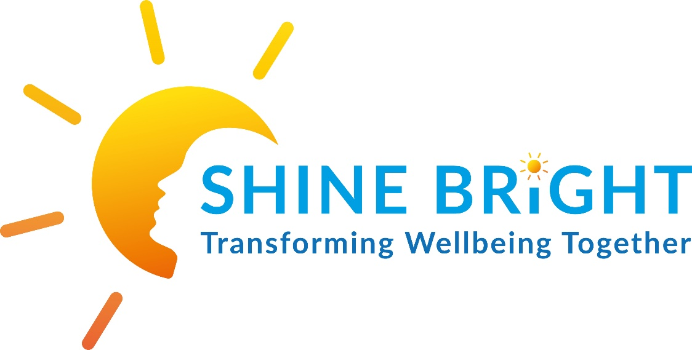

Nicola Swales
January 2025

