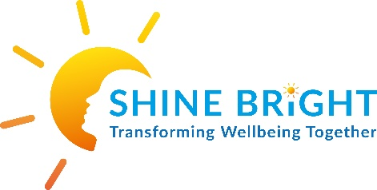
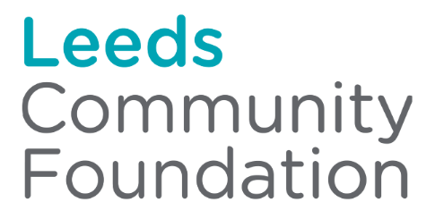

Shine Bright (NS) CIC
WRAP (Wellness Recovery Action Plan) Service
Year 2024-2025 Activity Report

Who we are and what we do
Shine Bright (NS) CIC is a Community Interest Company set up to support children, young people’s and young adults (0-25yrs old) emotional and mental health needs across Leeds and Yorkshire. Shine Bright provides group and individual mental wellbeing and holistic youth work support that aids children, young people and families to transform their wellbeing together. The support teaches communities to self-care, to get well and stay well, to support others and to prevent crisis now and in their future. Support is offered through bespoke creative, and activity based individual therapeutic support sessions, group drop-ins, a structured 12-week WRAP©️ ‘Wellness Recovery Action Plan ®’ peer support group programme, an ongoing peer support group provision for all WRAPped individuals and the opportunity to become a trained volunteer and even paid peer facilitator of future groups.
Shine Bright is guided by the ethics of WRAP©️ ‘The Wellness Recovery Action Plan ®, which is an evidenced wellness programme that offers sustained, longer-term behaviour change through the creation of a personalised Wellness Plan and Crisis Plan per individual. The founder of Shine Bright is an Advanced Practitioner of this approach and advocates the benefits of trauma informed practice, lived experience and peer support, utilising the strengths and skills of its communities. Shine Bright individual support is embedded in the ethics and values of Youth and Community Work practice, providing flexible, co-designed support that is relevant and effective for our young communities. Lastly Shine Bright fosters community assets by providing the opportunity for communities to upskill and learn to support their peer communities through training, volunteering and employment, under the supervision and guidance of trained WRAP facilitators and Advanced Practitioners.

“Shine bright helped me understand what I was feeling was usual and wasn’t wrong. It was a safe and easy place to go, since at the time I joined there wasn’t anywhere offering the type of support I needed. It helped me make connections and new friends which are a good support system” Young Person
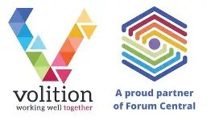
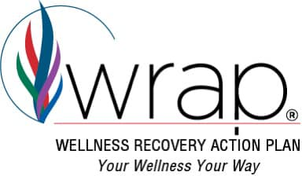

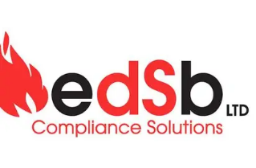

YR 2024-2025

Funding in 2024 - 2025:
Shine Bright, during 2024-2025 sadly said farewell to the 2yr funding stream from Leeds Community Foundation – Trauma Informed Grants, as this programme in Leeds closed its financial support, receiving its final instalment in June 2024 to complete evaluation and training, with a final celebration event in October 2024. Shine Bright (NS) CIC remains part of the Compassionate Leeds programme born from the learning of the Trauma Informed Grants and continues to share best practice. Click here to watch our spotlight
Shine Bright was lucky enough to be chosen as one of twenty-four VCS organisations in Round 2 and in Jan 2025 announced as one of nine, Round 3: Transforming Mental Health Grant holders in Leeds. Funding is secured until 2028 for us to provide mental health support to transition age young people, 17-25yrs old in Leeds, who experience complex mental health difficulties.
A one-off corporate donation from EDSB was awarded to provide our young people groups fun activity trips out. We look to secure more corporate donations in the future.
Consultancy and Just Giving donations continue to bring in a small income, which we hope to expand upon in the future as we deliver training, deliver WRAP for others and expand our fundraising efforts.

Activity in 2024-2025

Shine Bright has provided the following support to young communities across Leeds and Yorkshire this year:

Children’s support up to age 12yrs old.

- A 12-week WRAP programme was established focusing on those pupils transitioning from primary to YR7 in secondary schools. This group engaged 10, 10-11yr olds in support, with 8 completing the WRAP programme and 7 moving into the ongoing peer support group that was provided fortnightly throughout the year 2024-2025. Shine Bright sustains this resource post the ending of the Trauma Informed funding, continuing vital support for our children cohort and goes on to engage wider local children in its support in 2025. Feedback can be found in the evaluation at the end of the report.

Young People’s support - 13-18yrs old

- An ongoing peer support group for those young people who have completed a WRAP previously, continued to run, engaging 16 young people that regularly attended this fortnightly support group throughout the year. Shine Bright sustains this resource post the ending of the trauma informed funding, continuing vital support for our young people cohort. Feedback can be found in the evaluation at the end of the report.
- EDSB corporate sponsor funded 3 trips out for the young people peer support group. The young people chose how to spend the funds opting for laser zone, pizza hut and bowling. EDSB SUPPORTING BRIGHTER FUTURES - EDSB Compliance Solutions

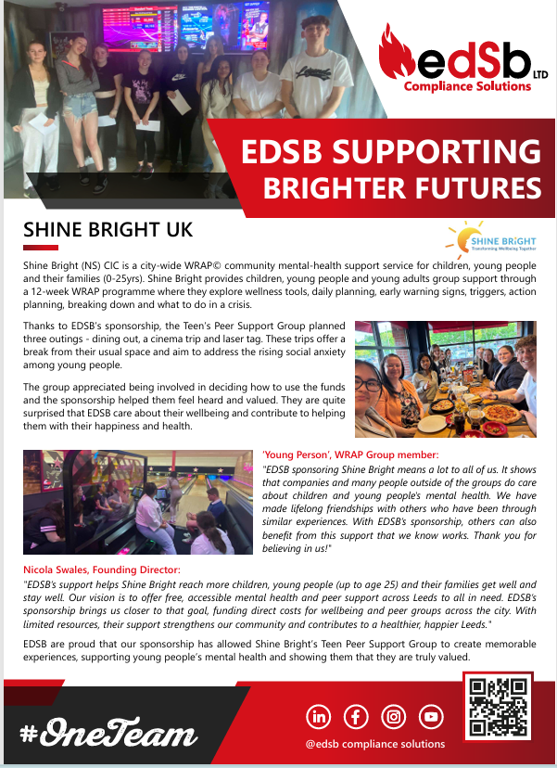

21 children and young people were supported on an ongoing basis through the peer support element of Shine Bright support this year. Shine Bright continues to source funding to be able to offer more children and young people WRAP support across Leeds, in the meantime the peer support element is maintained with Shie Bright funds.

Demographics

Gender
Male = 5, Female = 16 and 1 male, 1 female trained peer facilitators.

Ethnicity

White British = 16
White/Other = 1 + 1 trained peer facilitator
Black / Caribbean = 2
Mixed/Asian = 2 + 1 trained peer facilitator

Age

10 = 1 11 = 6 14 = 2 15 = 5 16 = 4 17 = 3 and 2 trained peer facilitators = 21

Postcode

LS6 = 5
LS7 = 8
LS8 = 3
LS14 x 1
LS16 x 1
LS17 x 3

= Support offered locally and citywide

Cohorts

In Education – 19
Leaving Care – 1
LAC – 1
LGBTQ - 3
Neurodiverse - 5
SEND - 1
NEET – 2
Mental health service user – 7

Young Adults support - 17-25yrs od.

With Transforming Mental Health Round 2 funding , Shine Bright continued to roll out and embed the WRAP©️ ‘The Wellness Recovery Action Plan’ offer across adult mental health pathways. We focused on engaging transitional age communities, 17-25yrs old with complex mental health needs, who can often struggle to move from Children Services to Adult Services, to meet thresholds or find the right ‘fit’ with adult mental health support. We hoped this investment in WRAP Transitional support would bridge the gap often experienced by these young adults at a vital time of their development and mental health recovery journey.
We note mental health support interventions are often time limited across the city and we hoped to offer an alternative, long term support for this age range. WRAP provides an ongoing peer support element and community asset training programme built into the model, preventing a cliff edge to support as is often experienced when support ends.

During 2024-2025 Shine Bright delivered
- 2 x 12-week Transition age WRAP programmes with space for up to 15 young adults in each group,
- an ongoing peer support group offering sustained support post WRAP,
- built in vital 1:1 outreach support sessions for active participants and new referrals
- undertook consultations and participation activity to learn from our communities recommendations and best practice
- refreshed existing peer facilitators qualification via 5-day WRAP Facilitator Training with Missing Peace CIC in Keighley (a fellow WRAP service). Alongside the peer facilitators, 4 community VCS services were trained and qualified in the Keighley area.
- Planned a 3-day WRAP facilitator training programme for Transition age participants supported this year, in Summer 2025 alongside Barnardos Children’s Charity practitioners.

Timescales throughout the project were pushed back due to delays in reaching and engaging the correct cohort. Recruitment of those vulnerable transition aged adults with complex mental health needs proved to be slow, resource heavy and unpredictable. This cohort are in the most part extremely cautious, often mistrusting of services and support, let down and highly socially anxious. They move in and out of crisis as they attempt to be independent, make decisions about their future and face financial, education and employment pressures. Shine Bright this year worked hard to adapt the accessibility of its support by adding several engagement drop-in sessions to the beginning of the structured 12-week WRAP sessions. Ploughed lots of resource and capacity into adapting the referral process and 1:1 outreach and/or blended support offer aiming to reduce any barriers that may exist to engaging.

Demographic information of young adults

Round 2 funding saw 32 Transition age young adults were and continue to be supported long term in drop-ins, group sessions, through 1:1 support - face to face, online and via the phone. Shine Bright has had direct contact and influence with 12 parents/carers linked to these young adults.
5 young adults referred chose not to take up support at this time. 13 young adults referred in Round 2 are hoping to be engaged in the next year. Shine Bright has made initial contacts with all. In total 49 young adult referrals were received in Round 2 with 61 individuals - young adults and parents/carers attached.

Referral routes are primarily from CAMHS Transition Team (in the majority), Leeds Mental Wellbeing Service/Primary Mental Health Team, CAMHS, Mindmate Support Team, Gipsil, Bereavement Services, Parent/Carer, Self/Young Adult, Leaving Care Team.

We hope to link further with Wellbeing Connectors and all Local Care Partnership Hubs. Connections have been made with the Light and Leeds University LCP and connected wellbeing connectors.

Demographic Breakdown
The demographic breakdown for the 32 individuals actively engaged in support so far are presented below. The demographic data of the 13 young adults referred and currently being engaged will be presented in next year’s data.

Gender
Male = 9, Female = 22, Non-Binary = 3

= Groups accessible to all. Retention of Males in wellbeing model proves more difficult as expected. The outreach individual support is proving successful to engaging them, building trust and supporting them slowly into groupwork.

Ethnicity

White British = 21
White/Other = 4
Pakistani = 2
Black / Caribbean = 3
Mixed/Asian = 2

= engaged 66% White British, 34% diverse communities

Age

17 = 12 18 = 12 19 = 4 21 = 2 22 = 1 23 = 1

= supported from 17-23yrs old in Round 2

Postcode

LS6 = 3
LS7 = 2
LS8 = 3
LS10 = 1
LS11 = 6
LS12 = 2
LS14 x 5
LS16 x 1
LS17 x 5
LS22 = 1
LS28 = 1
WF10 = 2

= Support offered citywide.

Cohorts

Higher Education - 12
Supported Accommodation – 1
Leaving Care - 3
LGBTQ - 3
Neurodiverse - 10
SEND - 2
NEET - 14

Impact of the Support
Evidenced Based Outcome Measures used to evidence the impact of the 12-week WRAP programme
Shine Bright, WRAP programme utilises two scales to evidence its impact, these are the evidenced based outcome measures The Warwick-Edinburgh Mental Wellbeing Scale (WEMWBS) and Goal Based Outcomes (GBO). These scales run alongside traditional qualitative group and service satisfaction evaluation tools. The young people at Session 1 and 12 are asked to complete these measures and/or at the beginning and end of individual support. The scales, measure changes in wellness due to a therapeutic intervention and map out personalised goal setting and attainment and next steps.

18 individuals completed initial and final measures out of 32 engaged, enabling Shine Bright to measure the impact the support offer has made. 12 in support are yet to complete a second measure, which Shine Bright will source. 2 finished support without completing a measure. The reason some participants did not complete the measure were due to them experiencing severe anxiety and/or mental health crisis, low self-esteem and lack of ability to socialise with peers and be present in the group setting, busy with exams and chaotic and unstable life situations interrupting their engagement. Shine Bright will source these outcomes in a trauma informed way that complements their ongoing support.

We can see from the below evidence that the impact of the WRAP model in Round 2, for those that engage, is ‘significantly’ positive on an individuals’ wellness and personalised goals, mental health and prevention from crisis, despite the complexities that the Transition age adults present with.

The goal-based outcomes (GBO) tool is a simple and effective method to measure progress and outcomes of an intervention. It can be used in any setting, which is change-focused and goal-oriented and helps all parties to understand whether the intervention is helping young people make progress towards the things that they really want help with.
Using the Goals Based Outcomes, young people outlined that the purpose of attending the WRAP group was to achieve their personalised goals, which fit into the below themes:

- Improve Social Anxieties and skills
- Improve Mental health – understanding, expressing and managing
- Improve Confidence and Self Esteem
- Build Life Skills and see a Future

Once a goal has been set (column 1 below) the next step is to gain the initial (time 1 or baseline) rating out of 0 - 10 for the goal (column 2 below). 0 represents ‘Goal not met at all’, 10 represents ‘Goal fully met’ and 5 is ‘halfway to reaching the goal’. Young people can set up to 3 goals with this measure. By collecting a follow up measure, Time 2 (T2 in column 3 below), the distance travelled towards achieving that goal can be evidenced (column 4 below). T2 was measured at Session 12 for the WRAP programme

Goals Based Outcomes
Personalised Goal set by Young Adult | Initial measure  T1 | Final Measure  T2 | Distance travelled | % improvement + / decline -
Social Anxieties and Social Skills
To stop feeling like I get left behind by people, to talk in the group more | 2 | 7 | +5 | 50%
To make more friends | 7 | 10 | +3 | 30%
To help me make new friends | 3 | 9 | +6 | 60%
To get more friends | 5 | 8 | +3 | 30%
To come out of my house to come to a group | 5 | 9 | +4 | 40%
Make new friends and learn wellness tools from them | 5 | 9 | +4 | 40%
To be more comfortable being social | 3 | 3 | 0 | 0%
To improve confidence by introducing new ways to promote positivity. 0. 2 | 0 | 2 | +2 | 20%
To make friendships and talk about how I feel | 3 | 8 | +5 | 50%
To be less anxious, and to make more connections | 2 | 4 | +2 | 20%
To practice my social skills | 4 | 8 | +4 | 40%
To make new friends. 9. 10 | 9 | 10 | +1 | 10%
Mental Health – Understanding, Expressing and Managing
To improve mental health | 3 | 6 | +3 | 30%
To get better with my self-harm | 5 | 9 | +4 | 40%
To learn how to express my feelings | 0 | 6 | +6 | 60%
Turn on how to calm down when I feel angry | 4 | 8 | +4 | 40%
To get better with my mental health improves on not feeling depressed and get myself out of my depressive state | 2 | 7 | +5 | 50%
To understand my limits and boundaries before things dip | 4 | 4 | 0 | 0%
To create strategies for one mental health dips | 5 | 6 | +1 | 10%
To be able to execute my strategies | 3 | 3 | 0 | 0%
Allowing myself to make mistakes and be okay with it | 3 | 4 | +1 | 10%
To help cope with my feelings better | 1 | 4 | +3 | 30%
To improve my mental health. 5. 10 | 5 | 10 | +5 | 50%
Forget about bad things like bullying | 5 | 8 | +3 | 30%
To try to be mindful and happy | 5 | 9 | +4 | 40%
To help cope with my feelings better | 1 | 4 | +3 | 30%
To learn how to manage emotions through well-being plans | 0 | 2 | +2 | 20%
To change perspective and learn to understand the way I feel | 1 | 1 | 0 | 0%
I would like to find well-being strategies that I can commit to daily | 0 | 7 | +7 | 70%
To talk about my feelings | 5 | 8 | +3 | 30%
Do you know how to support myself and how others can support me | 2 | 5 | +3 | 30%
To talk about my feelings | 5 | 8 | +3 | 30%
Confidence and self esteem
To improve my overall confidence | 4 | 8 | +4 | 40%
To build my self-confidence | 4 | 7 | +3 | 30%
To increase my confidence | 5 | 9 | +4 | 40%
To build confidence to be able to publish poetry | 2 | 4 | +2 | 20%
Finding my own personality, not basing it on who I am with or my environment. | 4 | 5 | +1 | 10%
To be able to leave the house and feel safe | 0 | 4 | +4 | 40%
To socialise with others | 5 | 10 | +5 | 50%
To be able to work with other people similar to me | 7 | 10 | +3 | 30%
To help gain confidence | 6 | 9 | +3 | 30%
I would like to be able to voice my opinion and share confidently | 1 | 8 | +7 | 70%
Allow my confidence to grow | 3 | 8 | +5 | 50%
Life Skills and future
help me to control my life and feelings | 3 | 7 | +4 | 40%
To become more independent | 2 | 8 | +4 | 40%
To want to try new things | 5 | 7 | +2 | 20%
To go to Liverpool for college | 0 | 3 | +3 | 30%
Not let the past, hold me back, feeling guilty about my sexuality, try and get on with life better | 2 | 8 | +6 | 60%
To encourage inspire others to find comfort and support and to develop their skills | 1 | 9 | +8 | 80%
To get a secure job | 0 | 0 | 0 | 0%
To move out | 0 | 0 | 0 | 0%

What the data tells us:

We can see that within 12 weeks exposure to the WRAP programme, young people:

- Improved from 10% - 60% in ‘Social Anxieties and Social Skills Goals. The mean average being 32.5% improvement after 12 weeks. One individual made no improvement to their goal due to experiencing crisis at the time of the measure. No declines in goals were experienced.

- Improved from 10% - 70% in their ‘Mental health – understanding, expressing and managing’ goals. The mean average being 30% improvement after 12 weeks. One individual had set 3 mental health goals and made no improvement (0%) on these due to experiencing crisis at the time and breaking from support for a few months. She is now back in individual support sessions to help maintain her wellness. No declines in goals were experienced.

- Improved from 10% - 70% in Confidence and Self Esteem’ goals. The mean average being 37% improvement after 12 weeks. No decline in goals were experienced.

- Improved from 20% - 80% in their ‘Build Life Skills and see a Future’ goals. The mean average being 34% improvement after 12 weeks. One individual made no improvement to their goals due to these goals being set outside the parameters of the group – to ‘move out, find a job’. Economics, Cost of Living and Age (17yrs) play factors in reaching these goals. Shine Bright will support individually and signpost for her to realise these goals in her future.

The Goals Based Outcome (GB0) measures in Round 2 show a maintaining or improvement on all goals set by participants after 12 weeks, ranging from 10%-80% and the average mean of the 53 goals set 24% improvement. There are no decline in scores, WRAP has a 100% maintaining and improvement rate on goals
The young people have further opportunity to continue to work on these goals with Shine Bright as they are invited to an ongoing Peer Support Group for all WRAPped individuals, for an unlimited period. GBO demonstrates that WRAP is an effective change focused and goal orientated intervention.

WEMWBS
The Warwick-Edinburgh Mental Wellbeing Scale (WEMWBS)

WHAT IS WEMWBS?

The Warwick and Edinburgh Wellbeing Scales were developed to enable the measuring of mental wellbeing in the general population and the evaluation of project and programmes that aim to improve mental wellbeing. The scales support positively focused interventions, and all items inquire about positive aspects of mental health making it an accessible measure for our young people and practitioners to engage with. The 14-item scale WEMBWBS has 5 response categories, summed to provide a single score. The items are all worded positively and cover both feeling and functioning aspects of mental wellbeing.

The measure provides Shine Bright with a great deal of information to evidence the impact that WRAP can and does have on young people as part of this project. Two measures are taken as with the GBO’s, in session 1 (Time 1) and session 12 (Time 2). The total score is obtained by summing the score for each of the 14 items. The scoring range for each item is from 1 – 5 and the total score is from 14-70. Scores are collated to provide a Sum as a single number representing the level of wellbeing per individual and overall, at that point in time.

Scores can be divided into High, Average and Low mental wellbeing, as can be seen below in WEMWBS calculator detailing our real data from this project. High wellbeing is identified as a score of 60 and above, average mental wellbeing is a score of 43-59 and low is a score of 42 and below. WEMWBS ‘guide to scoring’ advise that a score of 41-44 is indicative of possible/ mild depression and a score of <41 is indicative of probable clinical depression. We do not use the measure as a clinical tool as we are a social model of early help but understanding how others interpret and use the data enables us to identify where we may need to signpost and refer on to specialist services.

18 young people’s data was analysed as they had T1 and T2 data that can demonstrate impact and change. 14 young people that completed T1 data only, have been omitted from the score chart below. Their T2 scores will be sourced moving forward and their impact data will be presented then.
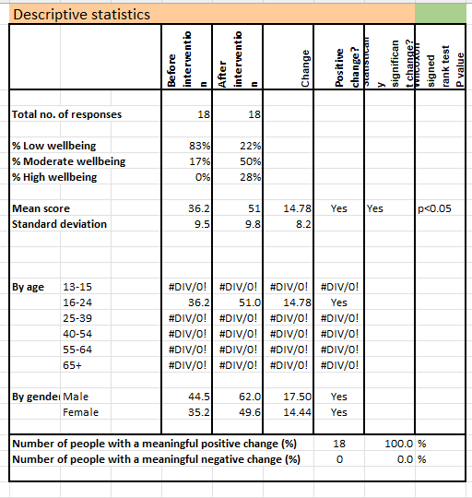

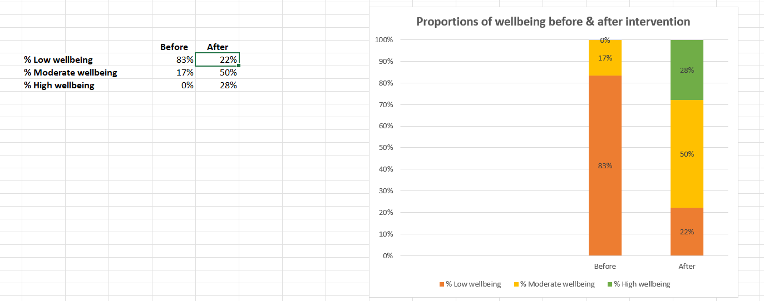

Before the WRAP programme young people’s mental wellbeing was - 83% Low, 17% Moderate and 0% High.

After the 12-week WRAP programme young people’s mental wellbeing is – 22% Low, 50% Moderate and 28% High. This evidences that the WRAP programme has had an overall positive impact upon young people’s mental wellbeing.

We can see:
- A decrease of 61% of low mental wellbeing experienced.
- An increase of 33% in moderate mental wellbeing and
- 28% of our young adults move into high mental wellbeing with the support from Shine Bright.

NB: High Mental Wellbeing is identified as a score of 60 and above, Moderate Mental Wellbeing is a score of 43-59 and Low Mental Wellbeing is a score of 42 and below.
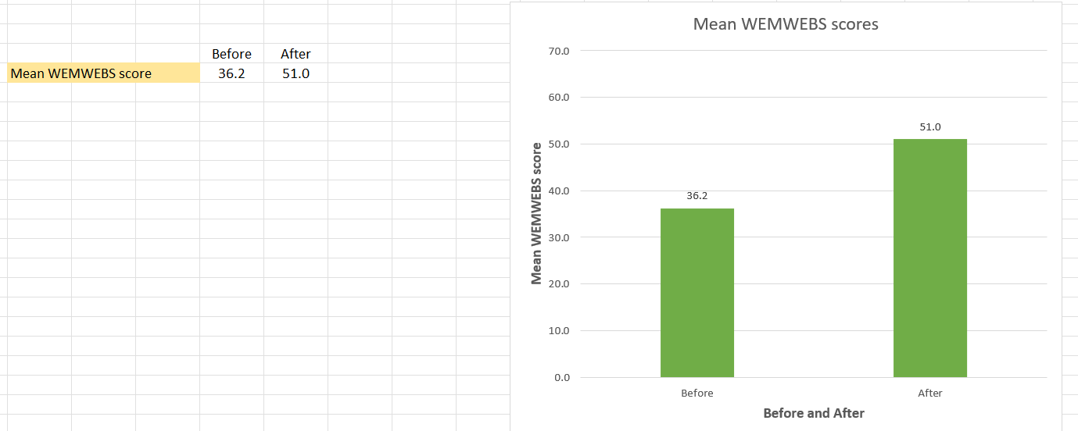

The mean impact of the project overall
The mean mental wellbeing score before the WRAP intervention was 36.2. This can be seen to fall within the Low Mental Wellbeing region and even according to WEMWBS guidance ‘a score of <41 is indicative of probable clinical depression’. We surmise that the young adults attending and completing the WRAP programme demonstrate an urgent need for mental wellbeing intervention that can both improve their mental health but also prevent their crisis. 14 out of 18 individuals were initially seen to score under <41, after the WRAP programme only 3 remained in this region.

After the WRAP intervention the mean mental wellbeing score is 51.0 seeing a 14.8 mean improvement/change. 51.0 falls midway in the Moderate Mental Wellbeing score range, demonstrating that Shine Bright’s WRAP support elevates young adults far away from the clinical region for probable depression (<41) and even mild depression that most exhibited.

According to WEMWBS interpretation tools, the data shows that WRAP has a ‘positive change’ and a ‘statistically significant change’ to the mental wellbeing of 100% of these young people.

Mean change per WEMWBS rating
Before
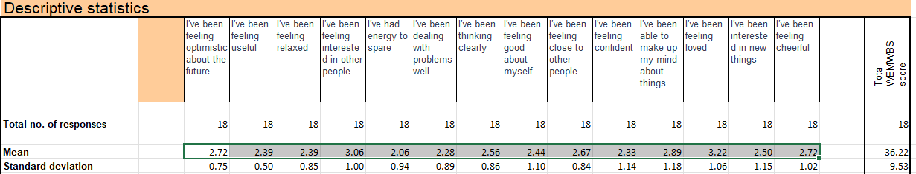

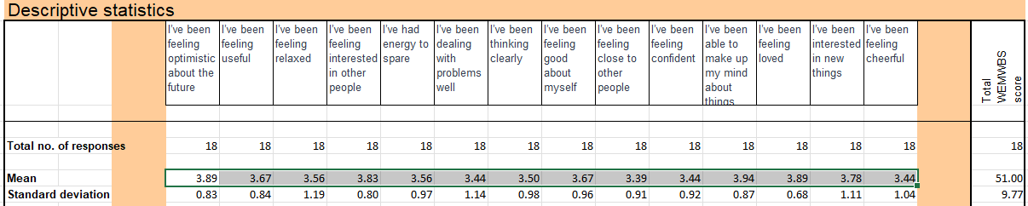
After

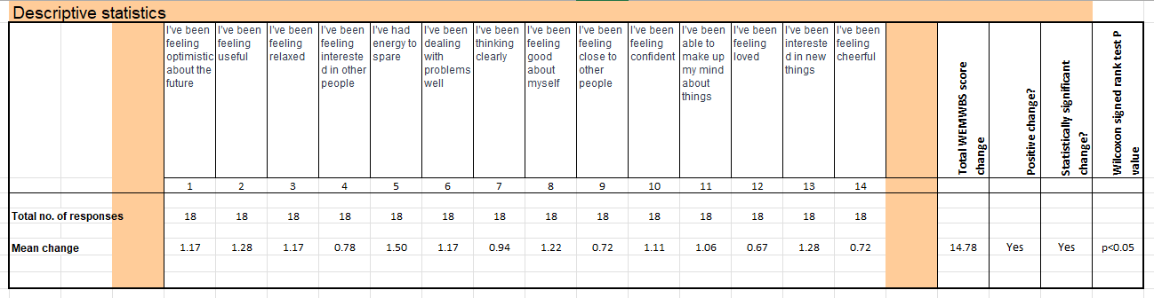
Mean Change

All scales are marked out of 1-5. On average

  - The lowest impact at mean 0.67 (4.5% improvement) is ‘I’ve been feeling loved’ and 0.72 (4.9% improvement) is ‘I’ve been feeling close to other people’ and 0.72 (4.9% improvement) ‘I’ve been feeling cheerful’.
  - the greatest impact has been ‘I’ve had energy to spare’ with a mean improvement of 1.50 (10% improvement).
  - This is followed by ‘I’ve been interested in new things’ and ‘I’ve been feeling useful’ with a mean improvement for both of 1.28 (9% improvement),

Looking at the individual scales, all 14 demonstrate a positive improvement / change for all the young adults
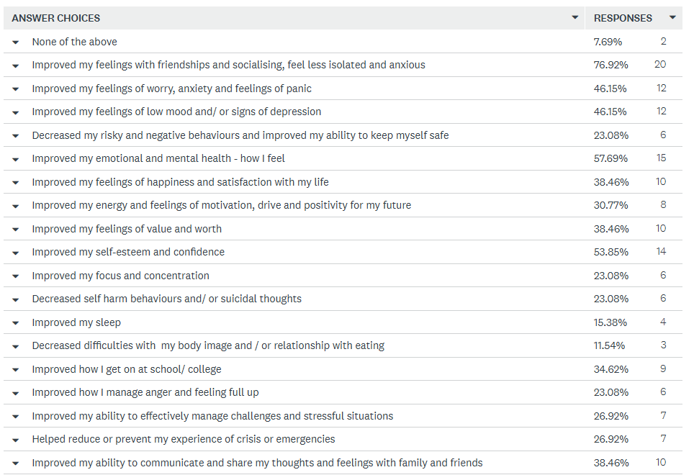
Feedback opportunity for all those engaged in support this year across WRAP programmes and peer support groups - April 2025 end of year consultation, via SurveyMonkey. Our young communities and their families tell us how Shine Bright helps:

- Shine bright has helped me with my mental health and ability to speak up and talk confidently about how I feel and what I want
- it has helped me become more confident talking to others and explaining my feeling to others. I am a very anxious person and now I feel less nervous around others
- Really helped me with social skills
- Shine bright improves individuals self-concept and their self-esteem regarding. Within my experience I have observed shine bright tailor their session plans to meet the needs of the individuals. I have found this to be really useful. Shine bright provides 1-1 support when you need it.
- My son has had some bereavement support sessions and they have helped a great deal. Shine bright is the next stage for him and although he hasn’t attended yet the support sounds crucial for my son and would only improve his mental wellbeing, therefore less likely to access NHS mental health services.
- Shine bright helps young people connect with each other and hear what each other are going through. Having his support system helps a lot with low moods and feeling lonely. Some people don’t talk to many people every day and having a group where you can connect with people is very important for people who are like this.
- Shine bright helps make new friends and social interactions with new people it is also fun
- Shine Bright helps young people have more confidence.
- Shine Bright helps young people to grow in confidence
- My daughter has only just started with shining bright but I already see her resilience growing. She has many demands to juggle and this has helped her feel she is empowered to manage her wellbeing better
Weekly support group in a safe environment that helps young people build healthy friendships, encourages self-esteem and teaches them about the impact their actions have on people around them. Learns team building and teamwork though activities provided.
- Shine Bright has enabled my child to have an outlet, to be able to open up & talk in a safe space without fear of being judged. Age, background, circumstance - it doesn't matter. They feel like they belong to something important & treated like a young adult, not someone's child or a school pupil.
- Shine bright has helped me to feel safe around other people . And to talk to them
- Shine Bright’s helped me tremendously as it allows me to socialise with people my own age and get advice from people going through/who have gone through similar situations. It helps me get advice from my peers that feels both personalised and helpful, rather than something read off a script. It is a safe space to escape the pressures of everyday life.
- Shine bright has been a god send I really don’t know where else we could have got the amazing support
- Very helpful to my daughter and she has thrived with the continuous support
- I think shine bright improves mental health massively as it’s a social setting and it’s a chance to talk to people of a similar age with similar issues
- Shine Bright not only improves social skills but helps young people understand who they are and that it is possible to find management strategies that work for them
- Shine bright and wrap gave my son somewhere to go to make friends, learn strategies for managing his emotions and to talk to sympathetic adults. Can’t thank them enough for their support.
- Having someone there to talk to when needed.
- My child attends and I feel that it’s a great source of positivity for her. She doesn’t realise it but I see a difference especially on the day she attends , she goes into the group one way and comes out a different person.
- Shine Bright gave my child the opportunity to meet peers in the community who were having similar experiences. It was the one place where they could relax and open up and feel less alone. Friendships were made and a mental health emergency was averted. My child went from expressing deep unhappiness and saying alarming things like ‘I don’t want to be here’, to feeling like a key part of a strong friendship group at Shine Bright.
- Shine bright helps to create communication across teens, fortnightly check-ins with blob trees helps people express how they are feeling and get to talk about their days and what they have done over the weeks that have passed. Fun activities and free time help with letting the teens communicate and get to know each other better whether being creative and making something or playing a game. The group helps create a space of being able to talk about struggles publicly and getting advice or separate one to one support.
- Shine bright spend a great deal of time and effort, engaging and not letting the individual fall through the gap. They are approachable, flexible and help me understand what to expect when using their support. They are very kind and approachable, and I can talk to them about anything. I don’t have to wait till my next session. If they are available, I can talk to them on the phone away from the group or session. Knowing that they are there helps me a lot and I love being able to talk to them about my child’s needs. They have helped my child Transition through many difficult moments in their life. It’s been a constant in my child’s life that created stability and lifelong friendships. She has been able to find a status where she has understood, is herself and does not hide. She looks forward to going. This has only been possible by the ongoing support provided by the peer support group after Wrap.
- It’s been brilliant for us. It turned things around for my child, made them feel normal and accepted. It was essential help at a key time in their life - if kids spend their formative years in hostile school environment where they feel isolated from friendship groups it can have a deeply damaging effect on their mental health long term, Shine Bright counters this and caught us just in time. Thank you.
- Shining bright seems to be the only thing available for struggling teens. Thank God it’s so effective
- Shine Bright has offered so much help but anxiety runs deep. Support is needed long term - the idea of no Shine Bright concerns my child.

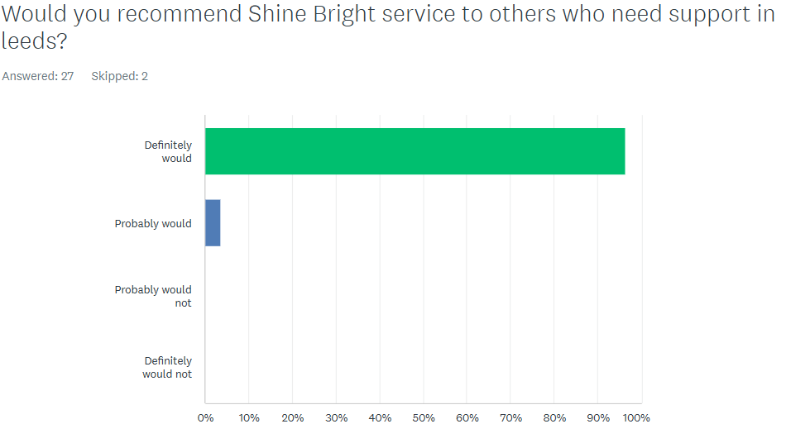
100% of our Young Adults and families ‘Definitely Would’ and ‘Probably Would’ recommend the Shine Bright support to others.

What Leeds Communities tell us:
This year, Shine Bright focused increasingly on participation and voicework ensuring we understand and meet the needs of young adults going forward. Shine Bright has undertaken consultations with Leeds communities since 2022. We wanted to update our learning keeping abreast of the current climate.
Shine Bright Needs Consultations ran in April 2025, with active families in support, highlight that our young communities’ main needs are:
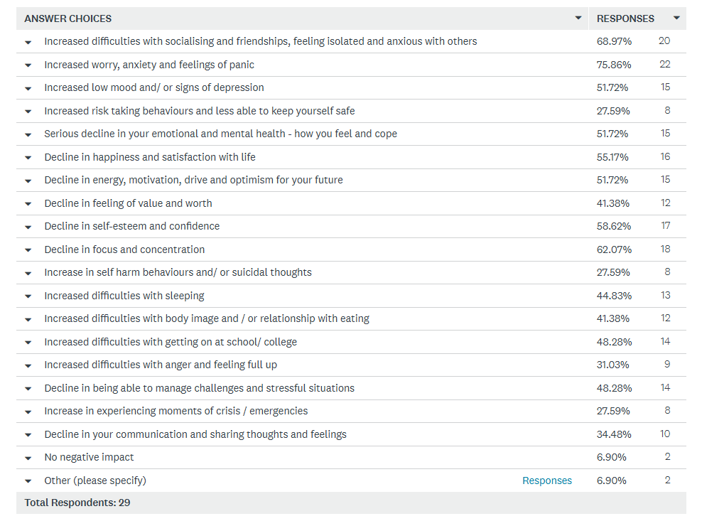

Other:
- Substance
- Inhibits opportunities for future self-actualisation as shutting off from world, damaging impact upon on education and then in turn future. Bereavement needs risen due to interrupted grieving processes not being able to go to funeral, increased deaths.
To meet these needs, Leeds communities designed the most Helpful mental health support: What we should adopt or do more of in Shine Bright.
- More social opportunities. Meet other young people, complete challenges, be introduced to new activities/opportunities. I guess it would look like a little like a group/club for young adults with role models and enthusiastic and motivated leaders/role models.
- Support groups that are made for people who are similar ages and are struggling with similar things
- One to one stuff and treat everyone equally coz of their needs
- It needs to consider the individual needs of each person and their way of opening up. Also helping people connect with others they can relate too
- Time spent listening to the needs of young people. There seems to be a sudden drop off in support & activities when young children become young adults, especially for those not interested in sport.
- Talking about it or doing something they really enjoy
- to be heard
- talking
- Caring a place of trust people who can relate
- Cooperative with children and young people to create a space where education is not a priority and understand is
- Exactly what Shine offer but perhaps more often than fortnightly.
- They need to be able to talk with peers in noncompetitive environment. They need to find friendships outside of school and hear from other young people who are having the same problems. This will help them feel less alone. Schools are super competitive in schoolwork but also in friendships, image, online activity - everything, kids aren’t allowed to show any weakness, it’s relentless pressure.
- Shine bright
- Opportunities to socialise in Safer Spaces different from just activity-based spaces, where emotional and mental health needs can be accepted, not judged and explored. To learn from each other with peers meetings together with similar experiences, enabling for young people to not feel isolated and alone. For those most anxious to offer outreach the park to engage into service. Service but does not shut their doors after two missed appointments but spends time to be accessible and engage these honourable young people. It’s to be based within the community accessible to the local area a blended approach of online support as well as face-to-face, individual and group support. it needs to be designed by young people and funders need to listen to what young people need at this moment in crisis. Ballistically sleep to be Matt, not just a mental health problem that they arrive with.

Communities tell us what the most Unhelpful mental health support is = What Shine Bright will not do! 27 respondents
- Shouting
- If workers are not kind
- Unfriendly workers
- Most services are inaccessible, underfunded and only accept Crisis cases. There is no compassionate or prevention planning.
- Feeling pressured to have to open up straight away without getting to know anyone you’re talking too
- Lack of easy access to support. GPs don't seem interested so where to turn to? Schools have too much on their plates & only bothered if affecting attendance.
- Not talking about it and keeping it to yourself. For services not really anything
- CAMHS. Social services. Foster carers neglect. Not enough training within schools and institutions. Police not dealing with mental health correctly. Services need to be more understanding of complex issues and be able to identify and resolve and come up with better safety plans for young people.
- People who are doing it for the money and not for the care of the people who need it
- Restricted support, conditions on attendance need to be less by the book and more incorporating
- Short term counselling e.g. one or two sessions
- Less talk more action
- Not sure, my child hates it when random ‘fun’ days/events are sprung on classes as a ‘treat’. For kids experiencing social isolation or anxiety these types of ‘rewards’ are actually a nasty surprise as they need to navigate outfits, seating plans on coach etc (my child doesn’t have special needs btw )
- School
- The most unhelpful support is where the professional is seems to be the fixer rather than working in partnership. Where it’s very short-term time limited and every referral cannot be bird within a year. Long waiting list of detrimental as young people asked us apart at the time in crisis, not when symptoms begin to show. It needs to be delivered in a child young person, friendly way Roseann and adopted adult style of mental health. It needs to be fun and creative, not too formal and surrounded by lived experience individual. They need to be opportunity for growth , and upscaling where the strength of these communities can be utilised within the service.

Shine Bright takes all learning from what our Leeds communities tell us and we adapt our practice and support offer accordingly. We can see the most common struggles facing our communities currently are social isolation and loneliness, anxiety and panic, low self-esteem and confidence and lack of focus and concentration. We listen to what communities identify as helpful support and work hard to offer these elements ad steer clear of unhelpful, inaccessible practice, again highlighted in the consultation.
Whilst working with the young adults especially, we have broadened our support to include drop-in engagement sessions pre-WRAP, 1:1 holistic youth work support sessions and provision of transport to aid accessibility and engagement needs and meet the more complex needs often presented by these individuals. The adaptations are proving effective and we will continue to co-design and co-deliver support with our young communities.

Conclusion
This Year, Transforming Mental Health funding has provided Shine Bright the opportunity to further demonstrate the impact that the WRAP (Wellness Recovery Action Plan) approach can have across it’s young communities and their families. Our outcome tools show a positive impact across the Transition age range 17-25yrs old, who became involved in the support within Round 2.
As evidenced through WEMWBS interpretation tools, the data shows that WRAP has a ‘positive change’ and a ‘statistically significant change’ to the mental wellbeing of 100% of young adults taking part in WRAP.

The WRAP model for Leeds is showing its power as a Comprehensive CAMHS early help and prevention resource, a step down from specialist support, a complementary intervention alongside specialist support or whilst on waiting lists, guarding against vulnerable communities falling through gaps in support. The 1:1 support sessions and ongoing peer support element increase the accessibility and impact our support has upon vulnerable young communities in Leeds. Now we look to the future to explore WRAP further with CAMHS Transition, Leaving Care, Higher Education, Schools, NEET, Teen pregnancies, the ‘Missing Middle’ (Children and young people with moderate to severe mental health concerns who experience difficulties accessing services) cohorts. We will continue to build on community assets and deliver support in partnership with our young communities.

We are committed to secure funds through a range of fundraising activities to enable this support offer to continue across Leeds and Yorkshire.
